**Bus Tap**

Project Documentation

Submitted to the Faculty of

School of Computing and Information Technologies of

Asia Pacific College

In Partial Fulfillment of the Requirements for the Course

Applied Projects 2

By

Anna Lynn C. Alcaraz

Sammy Boy M. Angot

Justin V. Besmano

Job G. Brioso

**ASIA PACIFIC COLLEGE**

Approval Sheet

BUS TAP

Prepared and Submitted by:

Anna Lynn C. Alcaraz

Sammy Boy M. Angot

Justin V. Besmano

Job G. Brioso

In Partial Fulfilment of the Requirements for the Degree of

Bachelor of Science in

Examined and Recommended for Acceptance and Approval for Research/Capstone Presentation

\_\_\_\_\_\_\_\_\_\_\_\_\_\_\_\_\_\_\_\_\_\_\_\_\_\_\_\_\_\_

Adviser

Panel of Judges

\_\_\_\_\_\_\_\_\_\_\_\_\_\_\_\_\_\_\_\_\_\_\_\_\_\_\_\_\_\_

Chairperson

Panel Members

\_\_\_\_\_\_\_\_\_\_\_\_\_\_\_\_\_\_\_\_\_\_\_\_\_ \_\_\_\_\_\_\_\_\_\_\_\_\_\_\_\_\_\_\_\_\_\_\_\_\_

Panel Member Panel Member

Acceptance and Approved in partial fulfillment of the requirements for the degree of Bachelor of Science

\_\_\_\_\_\_\_\_\_\_\_\_\_\_\_\_\_\_\_\_\_\_\_\_\_\_\_\_\_\_

Executive Director

School of Computing and Information Technologies

# Abstract

Passengers of the Bonifacio Global City (BGC) Bus have complained about the service of the BGC Bus company, mostly about how long the buses take to arrive at the bus stops. When implementing a bus passenger information system, passengers perceive deduced waiting time and better service from the company. With passenger information systems, passengers are informed about the services of the company and about the arrival time of the buses.

The group created a mobile application as the front-end and a web application as the back-end for the Bus Tap, a passenger information system for the BGC Bus, that aims to connect the BGC Bus company to its passengers. Through the Bus Tap, the BGC Bus company can provide its passengers with the latest information regarding their services, and passengers can access up-to-date information regarding the BGC Bus. Passengers can also contact the BGC Bus company through the mobile application, provide rating and feedback, send inquiries, and receive replies.

With the Bus Tap reservation feature, passengers no longer have to wait long to be able to ride the bus, having been able to reserve a spot on their desired schedule ahead of time, minimizing the waiting time they experience when taking the BGC Bus.

Table of Contents

[Abstract 3](#_Toc512501359)

[I. Introduction 8](#_Toc512501360)

[1.1 Project Context 8](#_Toc512501361)

[1.2 Purpose and Description 8](#_Toc512501362)

[1.3 Objectives 9](#_Toc512501363)

[1.4 Scope and Limitations 9](#_Toc512501364)

[II. Review of Related Systems 9](#_Toc512501365)

[2.1 BGC Bus 9](#_Toc512501366)

[2.2 Bus Passenger Information System 12](#_Toc512501367)

[III. Technical Background 13](#_Toc512501368)

[3.1 Integration Development Environment (IDE) 13](#_Toc512501369)

[3.1.1 Android Studio 13](#_Toc512501370)

[3.1.2 Visual Studio Code 13](#_Toc512501371)

[3.2 Programming Languages 13](#_Toc512501372)

[3.2.1 Java 13](#_Toc512501373)

[3.2.2 PHP 14](#_Toc512501374)

[3.3 Laravel 14](#_Toc512501375)

[3.4 XAMPP 14](#_Toc512501376)

[3.5 Database 14](#_Toc512501377)

[3.5.1 MySQL 14](#_Toc512501378)

[IV. Design and Methodology 15](#_Toc512501379)

[4.1 Requirements Analysis 15](#_Toc512501380)

[4.2 Requirements Documentation 16](#_Toc512501381)

[4.3 Gap Analysis 18](#_Toc512501382)

[4.4 Design of Software, Systems, Product, and/or Processes 19](#_Toc512501383)

[4.4.1 Functional Description Diagram 19](#_Toc512501384)

[4.4.2 Use Case Diagram 21](#_Toc512501385)

[4.4.3 Event Table 22](#_Toc512501386)

[4.4.4 Data Flow Diagram 23](#_Toc512501387)

[4.4.5 Entity Relationship Diagram 25](#_Toc512501388)

[4.4.6 Object Diagram 26](#_Toc512501389)

[4.4.7 Class Diagram 27](#_Toc512501390)

[4.4.8 Activity Diagram 28](#_Toc512501391)

[4.4.9 Sequence Diagram 32](#_Toc512501392)

[4.4.10 State Machine Diagram 38](#_Toc512501393)

[4.4.11 Timing Diagram 41](#_Toc512501394)

[4.4.12 Communication Diagram 43](#_Toc512501395)

[4.4.13 Package Diagram 44](#_Toc512501396)

[4.4.14 Component Diagram 45](#_Toc512501397)

[4.4.15 Deployment Diagram 46](#_Toc512501398)

[4.4.16 Composite Structure Diagram 47](#_Toc512501399)

[4.4.17 Interaction Overview Diagram 48](#_Toc512501400)

[4.5 Development and Testing 52](#_Toc512501401)

[4.6 Description of the Prototype 52](#_Toc512501402)

[V. Conclusions and Recommendations 59](#_Toc512501403)

[VI. References 60](#_Toc512501404)

[VII. Appendices 61](#_Toc512501405)

[7.1 Data Gathering 61](#_Toc512501406)

[Letter of Request for Interview to the management of the BGC Bus 61](#_Toc512501407)

[Questions for the Interview with the management of the BGC Bus 63](#_Toc512501408)

[Interview Transcript 64](#_Toc512501409)

[Survey Questionnaire 67](#_Toc512501410)

[7.2 Curriculum Vitae 69](#_Toc512501411)

**List of Tables**

[Table 1. Routes and Schedules of the BGC Bus 10](#_Toc512501412)

[Table 2. Problems encountered by BGC Bus passengers 15](#_Toc512501413)

[Table 3. Average waiting time 16](#_Toc512501414)

[Table 4. Software Requirements 17](#_Toc512501415)

[Table 5. Current System vs. Proposed System 18](#_Toc512501416)

**List of Figures**

[Figure 1. Web Application – Sign In Page 53](#_Toc512501443)

[Figure 2. Web Application – Sign Up Page 53](#_Toc512501444)

[Figure 3. Web Application – Send Password Reset Link Page 54](#_Toc512501445)

[Figure 4. Web Application – Reset Password Page 54](#_Toc512501446)

[Figure 5. Web Application – BGC Bus News Page 55](#_Toc512501447)

[Figure 6. Web Application – Bus Routes Page 55](#_Toc512501448)

[Figure 7. Web Application – Bus Stops Page 56](#_Toc512501449)

[Figure 8. Web Application – Stop Location Page 56](#_Toc512501450)

[Figure 9. Web Application – Bus Schedules Page 57](#_Toc512501451)

[Figure 10. Web Application – Buses Page 57](#_Toc512501452)

[Figure 11. Web Application – Reservations Page 58](#_Toc512501453)

[Figure 12. Web Application – Feedbacks Page 58](#_Toc512501454)

# Introduction

## Project Context

Bonifacio Global City (BGC) is one of Manila’s Central Business Districts. Companies, especially business process outsourcing (BPO) firms, have made BGC the base of their operations in the country. With its strategic location near EDSA (Epifanio de los Santos Avenue), C-5, and SLEX (South Luzon Expressway), BGC is accessible from all points of the Metro.

To travel from, to, and within BGC, the majority relies on mass transport, mostly, the BGC Bus. The BGC bus caters to 44,000 passengers daily on weekdays, and 20,000 passengers daily on weekends (Obias, 2017). The BGC Bus has a fleet composed of 51 buses with seating capacity of 37 passengers and additional 38 standing passengers (Obias, 2017). These buses are deployed to 12 bus routes to help commuters navigate their way around BGC: North, North Express, East Express, Upper West Express, Lower West Express, Central, Night, East, West, Ayala Express, ARCA South Express, and Nuvali Express.

With 44,000 daily passengers, the BGC Bus company has received complaints from the passengers regarding the long queue of passengers and long waiting time during peak hours (Obias, 2017). From the interview conducted by the group with the BGC Bus company, the company has stated that it aims to achieve a standard waiting time of 10 minutes. The group conducted their own observation regarding the waiting time of passengers during peak hours. From the data gathered, the longest waiting time was about 30 minutes and 44 seconds.

The Bus Tap aims to help the BGC Bus company achieve the standard waiting time of 10 minutes. The Bus Tap is a passenger information system for the BGC Bus. Passenger information systems provide passengers with information regarding the services of the transit company. Among the information passenger information systems provide are the trip schedules. From a study of the Department for Transport of the United Kingdom, one of the benefits of implementing a passenger information system are reduced perceived waiting time (Trapeze Group).

## Purpose and Description

The Bus Tap is a passenger information system that will provide passengers of the BGC (Bonifacio Global City) Bus with information (e.g. news and announcements, bus routes, bus stops, and bus schedules) regarding the BGC Bus.

Using the mobile application of Bus Tap, BGC Bus passengers can view the latest news and announcements from the BGC Bus company. Passengers can view information on all the bus routes (e.g. route map, operating schedule, bus fare, and stops), bus stops (e.g. location, beep card loading availability, bus ticket availability, and routes), and bus schedules (e.g. bus route, arrival time, and departure time). Passengers will also be able to reserve spots on the bus arriving closest to their selected bus schedule. Passengers can also send their rating and feedback, or inquiries regarding the BGC Bus.

Using the web application of the Bus Tap, employees of the BGC Bus company can post news and announcements to the passengers. Employees can add, view, update, and delete information regarding the bus routes, bus stops, buses, and bus schedules. Using the Bus Tap web application, the company will be able to receive reservations, rating and feedback, and inquiries sent by the passengers.

## Objectives

The Bus Tap aims to be able to:

* connect the BGC Bus company to the BGC Bus passengers;
* provide the BGC Bus passengers with information regarding the BGC Bus; and
* decrease the waiting time of BGC Bus passengers to 10 minutes.

## Scope and Limitations

The Bus Tap can only be used for the BGC Bus. The Bus Tap has a mobile application front-end and a web application back-end. Only the employees of the BGC Bus company can access the web application of the Bus Tap; therefore, BGC Bus passengers can only access the mobile application of the Bus Tap. Currently, the mobile application is available to Android devices only.

# Review of Related Systems

## BGC Bus

The BGC Bus has a fleet composed of 51 buses with each bus having a seating capacity of 37 passengers, but can fit a total of 75 passengers (Obias, 2017). These buses are deployed to 12 bus routes to help commuters navigate their way around BGC: North, North Express, East Express, Upper West Express, Lower West Express, Central, Night, East, West, Ayala Express, ARCA South Express, and Nuvali Express.

The North Route, North Express Route, East Express Route, Upper West Express Route, Lower West Express Route, Central Route, Night Route, East Route, and West Route only travel within BGC. The North Route operates from Mondays to Fridays only, from 6:30AM to 10:00AM and from 4:30PM to 8:30 PM. The North Express Route, East Express Route, Upper West Express Route, and Lower West Express Route also operates from Mondays to Fridays only, but from 6:00AM to 10:00PM. The Central Route operates every day from 6:00AM to 10:00PM, while the Night Route also operates every day but from 10:00PM to 6:00AM. The West Route and the East Route operate on Saturdays, Sundays, and during holidays, from 6:00AM to 10:00PM.

The extension routes, Ayala Express Route, Arca South Express Route, and Nuvali Express Route travel to Makati City, Taguig City, and Sta. Rosa, Laguna, respectively. These routes operate from Mondays to Fridays only during peak hours. Peak hours of the BGC Bus are from 6:00AM to 10:00AM and from 4:00PM to 10:00PM (Obias, 2017). The Arca South Express Route operates from 6:10AM to 9:00AM and from 4:00PM to 8:00PM. The Ayala Express Route operates only on mornings from 7:00AM to 10:00AM. The Nuvali Express Route only has one morning trip at 6:30AM, and two evening trips at 6:30PM and 7:15PM. Table 1 shows the routes and schedules of the BGC Bus:

Table 1. Routes and Schedules of the BGC Bus

|  |  |  |  |
| --- | --- | --- | --- |
| **Routes** | **Day** | **Time** | **Stops** |
| North | Weekdays | 6:30AM to 10:00AM and  4:30PM to 8:30 PM | North Station  Uptown Park Suites  Park Triangle  BGC Turf  The Globe Tower  RCBC  Net One  Bonifacio Stopover  Crescent Park West  Nutriasia  Uptown Mall  Uptown Parade |
| North Express | Weekdays | 6:00AM to 10:00PM | Edsa Ayala  HSBC  The Globe Tower  Nutriasia  BGC Turf |
| East Express | Weekdays | 6:00AM to 10:00PM | EDSA Ayala  Market! Market! |
| Central | Everyday | 6:00AM to 10:00PM | Market! Market!  One Parkade  RCBC  Net One  Bonifacio Stopover  Crescent Park West  HSBC  The Globe Tower  Nutriasia  University Parkway |
| Upper West Express | Weekdays | 6:00AM to 10:00PM | EDSA Ayala  Bonifacio Stopover  Crescent Park West |
| Lower West Express | Weekdays | 6:00AM to 10:00PM | EDSA Ayala  RCBC  Net One  Fort Victoria |
| Night | Everyday | 10:00PM to 6:00 AM | EDSA Ayala  McKinley Parkway  RCBC  Net One  Bonifacio Stopover  Crescent Park West  HSBC  The Globe Tower  Nutriasia  University Parkway  Market! Market!  One Parkade  RCBC  Net One  Bonifacio Stopover  Crescent Park West  Fort Victoria |
| East | Weekends | 6:00AM to 10:00PM | EDSA Ayala  HSBC  The Globe Tower  Nutriasia  University Parkway  Market! Market! |
| West | Weekends | 6:00AM to 10:00PM | EDSA Ayala  McKinley Parkway  RCBC  Net One  Bonifacio Stopover  Crescent Park West  Fort Victoria |
| Ayala Express | Weekdays | 7:00AM to 10:00AM | EDSA Ayala  Ritz Tower  MSE  PBCOM  RCBC Plaza  The Columns  City Gate  Security Bank  SGV Building  Glorietta 5 |
| Arca South Express | Weekdays | 6:10AM to 9:00AM and  4:00PM to 8:00PM | Arca South  Market! Market!  RCBC  Net One  Bonifacio Stopover  Crescent Park West  Nutriasia  Market! Market! |
| Nuvali Express | Weekdays | 6:30AM, 6:30PM,  and 7:15PM | Nuvali  Market! Market! |

Fare for each trip is Php 12.00 for all routes, except for Arca South Express Route and Nuvali Express Route; fare for the Arca South Express Route is Php 24.00. Tickets are not sold on board a BGC Bus. When taking the BGC Bus, passengers can either buy single-journey tickets or pay using their tap-and-go beep™ cards. Tickets are sold at cashier counters at BGC Bus terminals (e.g. Ayala, Market! Market!, and Bonifacio One Technology Tower) or from ticket sellers at selected bus stops (e.g. Bonifacio Stopover, RCBC, and Nutriasia).

## Bus Passenger Information System

A bus passenger information system allows a bus company to communicate with the bus riders (Trapeze Group). Through the passenger information system, bus companies can provide announcements, status updates, and bus schedules. With the passenger information system, passengers will know when the buses will arrive at the bus stops.

From a study of the Department for Transport of the United Kingdom, one of the benefits of implementing a passenger information system are reduced perceived waiting time (Trapeze Group). Because the passenger information system provides the schedule of the buses, passengers know when their bus will arrive.

Information can be passed to the passengers through the passenger information system in different methods: (1) wayside and transfer station signs, (2) website, (3) mobile website, (4) real-time SMS, (4) mobile applications, and (5) web services.

The Bus Tap is a passenger information system that passes information to the passengers through a mobile application. The mobile application can make the BGC Bus more accessible to new passengers, and can encourage more people to use the BGC Bus. The list of the bus routes and bus stops, map of the routes, location of the bus stops, operating schedule of the BGC Bus, bus fare, and trip schedules provided by the mobile application give new passengers all the information they need to ride the BGC bus.

The mobile application is also a great way to connect and engage the passengers. Through the mobile application, passengers can send their feedback, suggestions, and inquiries to the bus company. Through the website, the company can view the passengers’ feedbacks, suggestions, and inquiries, and be able to reply to each.

Through the Bus Tap, the BGC Bus company can release and update their information, and the public always has the most current information regarding their service.

# Technical Background

Android Studio and Visual Studio Code were used as the Integration Development Environment (IDE) for the mobile application and web application, respectively. Java and PHP were used as the programming language for the mobile application and web application, respectively. The web application was created using the PHP web application framework, Laravel. XAMPP was used as the web server and MySQL was used as the Relational Database Management System (RDBMS) for both mobile and web application.

## Integration Development Environment (IDE)

An Integration Development Environment is a software that provides basic programming tools such as editor, compiler or interpreter, and debugger. It also allows the programmers to run their code and test their program. It improves programmers’ productivity as the tools needed for development can be accessed in just a single software.

### Android Studio

Android Studio is an IDE used for developing Android applications. It was developed by Google. As such, it can integrate Google App Engines, such as Application Programming Interface (APIs) and features. Android Studio is the ideal IDE for android app development.

### Visual Studio Code

Visual Studio Code is an IDE with many helpful features: syntax highlighting, bracket matching, auto-indentation and snippets. Aside from these features, developers can also add more functionality through the community created VS code extensions (code.visualstudio.com, 2018). It also supports Git. Visual Studio Code is the ideal IDE for developing web application using PHP because it helps the developers to be more productive and perform tasks workflow faster since it has many features including the IntelliSense code completion and code refactoring.

## Programming Languages

### Java

Java is a high-level programming language. Java can run in different platforms, such as Windows and Unix. It is based on the syntax of C and C++ programming languages but is an object-oriented programming language which contains classes and methods. Java is the programming language used for developing a mobile application in Android Studio.

### PHP

PHP is a scripting language used for creating dynamic and interactive web pages. PHP is also generally compatible with any web server, including Apache.

## Laravel

The web application of the Bus Tap was created using the web application framework, Laravel. Laravel supports the Model View Controller (MVC) architecture. The MVC architecture separates an application into three components: the model, the view, and the controller. The Model component corresponds to all the data-related logic that the user works with. This can represent either the data that is being transferred between the View and Controller components or any other data in the database. The View component is used for all the UI logic of the application. Controllers act as an interface between Model and View components to process all the business logic and incoming requests, manipulate data using the Model component and interact with the Views to render the final output.

## XAMPP

XAMPP is a free and open-source platform web server. It consists of the Apache HTTP Server, MariaDB Database and interpreters for scripts written in PHP and PERL programming languages. XAMPP allows developers to create a local web server for web applications.

## Database

A database is a collection of related records or data. One type of database is the relational database. It uses a structure that allows users to identify and access data that is in relation to another data in the database. Relational databases are often organized into tables. A Relational Database Management System (RDBMS) is a program that allow users to create, update and manage a relational database. To access the database, Structured Query Language (SQL) is used.

### MySQL

MySQL is the most popular open source RDBMS. The advantages of using MySQL is that it is easy to use, inexpensive, and reliable. MySQL is included when installing XAMPP. To access MySQL, the Apache web server and MySQL must be running in the XAMPP Control Panel. Clicking the Admin button of MySQL opens a web browser that will display all the databases.

# Design and Methodology

## Requirements Analysis

The group conducted an interview with the Assistant Operations Manager of the Bonifacio Transport Corporation to gather information regarding the BGC Bus (refer to Appendices for the Interview Transcript). From the interview, information regarding the BGC Bus such as available bus routes and bus stops, operating schedule, bus fare, number of buses in the fleet, passenger capacity of each bus, number of daily passengers, peak hours, peak seasons, bus route with the highest number of passengers, and passenger complaints were gathered.

The group conducted a survey amongst passengers of the BGC Bus (refer to Appendices for the Survey Questionnaire). The passengers were asked about problems encountered when riding the BGC Bus (e.g. long queue when buying bus ticket or loading beep™ card, long queue when waiting for the bus, inaccurate bus schedules, congestion of passengers inside the bus). Table 2 shows the results of the survey about the problems passengers encounter when riding the BGC Bus.

Table 2. Problems encountered by BGC Bus passengers

|  |  |  |
| --- | --- | --- |
| **Problems encountered when riding the BGC Bus** | **Passengers who encountered**  **the problem** | **Percentage (%) out of 60 passengers** |
| long queue when buying bus ticket or loading beep™ card | 5 | 8% |
| long queue when waiting for the bus | 45 | 75% |
| inaccurate bus schedules | 35 | 58% |
| congestion of passengers inside the bus | 15 | 25% |

From the results of the survey, most of the passengers do not encounter problems regarding long queue when buying bus ticket or loading beep™ card. Most of the passengers only take 1-2 minutes to buy ticket or load beep™ cards at the teller booths.

Most of the passengers also do not encounter problems regarding congestion of passengers inside the bus. Buses of the BGC Bus can accommodate 75 passengers, having a seating capacity of 37 passengers and can accommodate additional 38 standing passengers (Obias, 2017).

Passengers were also asked about the average number of minutes they usually wait for the BGC Bus. Table 3 shows the results of the survey about the average waiting time of the passengers for the BGC Bus.

Table 3. Average waiting time

|  |  |
| --- | --- |
| **Average waiting time before boarding the BGC Bus** | **Number of passengers** |
| 1-5 minutes | 6 |
| 6-10 minutes | 5 |
| 11-15 minutes | 24 |
| 16-20 minutes | 15 |
| 21-25 minutes | 0 |
| 25-30 minutes | 5 |
| more than 30 minutes | 5 |

The goal of the BGC Bus company was to achieve a standard waiting time of 10 minutes. From the survey conducted by the group, more than half of the passengers of the BGC Bus have encountered problems regarding the long queue when waiting for the bus, with 40% having to wait for 11-15 minutes, 25% having to wait for 16-20 minutes, 8% having to wait for 25-30 minutes, and another 8% having to wait for more than 30 minutes. Out of 60 BGC Bus passengers surveyed, 81% or 49 passengers answered having to wait for the bus for longer than 10 minutes.

BGC Bus passengers were also asked if an app for the BGC Bus would be useful and which features the passengers would like the app to have. Fifty passengers or 83% answered that the passengers of the BGC Bus would find an app useful.

From the survey, passengers regard the long waiting time as the problem of the BGC Bus. The Bus Tap aims to prevent or minimize the problems encountered by the passengers of the BGC Bus. With the reservation feature provided by the Bus Tap, passengers can reserve spots to the bus ahead of time, and skip the long queues, minimizing the amount of time spent waiting for the bus.

The group observed the operations of the BGC Bus. The group bought a beep card and bus tickets to pay for the bus fare. During the group’s observation, even during rush hours, loading the beep card at the BGC Bus terminals or buying tickets at the terminals and stops do not take more than a minute. Passengers wait in line at the stops or terminals to wait for the bus to arrive. During the group’s observation, the waiting time varies. The longest waiting time the group experienced is 30 minutes and 44 seconds at the Crescent Park West stop for the bus going back to the BGC Bus Ayala Terminal. When the bus arrives, passengers ride the bus in a first-come-first-serve basis. When the bus seats are all occupied, passengers can either choose to stand inside the bus or take the next bus. The bus then takes the route it was assigned, stopping at all the stops in the route.

## Requirements Documentation

The Bus Tap must have a front-end and a back-end. The front-end of the Bus Tap must be a mobile application, accessible by the public, running using the Android operating system; thus, the mobile application must be available to Android users. The back-end of the Bus Tap must be a web application, accessible only to the employees of the BGC Bus company. Table 4 shows a summary of the software requirements.

Table 4. Software Requirements

|  |  |  |  |
| --- | --- | --- | --- |
| **Software Requirements** | | | |
| **Module** | **User/Entity** | **Feature** | **Status** |
| Manage Accounts | Passenger,  Employee, Manager | Sign Up | Done |
| Sign In | Done |
| Sign Out | Done |
| Reset Password | Done |
| BGC Bus News | Employee, Manager | Add News | Done |
| Edit News | Done |
| Delete News | Done |
| Passenger,  Employee, Manager | View BGC Bus News | Done |
| View News Article | Done |
| Bus Routes | Employee, Manager | Add Route | Done |
| Update Route Information | Done |
| Delete Route | Done |
| Passenger,  Employee, Manager | View Bus Routes | Done |
| View Route Information | Done |
| Bus Stops | Employee, Manager | Add Stop | Done |
| Update Stop Information | Done |
| Delete Stop | Done |
| Passenger,  Employee, Manager | View Bus Stops | Done |
| View Stop Information | Done |
| Buses | Employee, Manager | Add Bus | Done |
| Update Bus Information | Done |
| Delete Bus | Done |
| View Buses | Done |
| View Bus Information | Done |
| Bus Schedules | Employee, Manager | Add Schedule | Done |
| Update Schedule | Done |
| Delete Schedule | Done |
| Passenger,  Employee, Manager | View Schedules | Done |
| View Schedule | Done |
| Reservations | Passenger | Reserve Spot | Done |
| Passenger,  Employee, Manager | View Reservations | Done |
| View Reservation Details | Done |
| Feedbacks | Passenger | Provide Rating and Feedback | Done |
| View Rating and Feedback | Done |
| Passenger, Employee, Manager | View Feedbacks | Done |
| Inquiries | Passenger | Send Inquiries |  |
| Employee, Manager | Send Replies |  |
| Reports | Manager | Generate Reports |  |

## Gap Analysis

Table 5. Current System vs. Proposed System

|  |  |  |
| --- | --- | --- |
| **Proposed System** | **Current System** | **Remarks/Impact** |
| The BGC Bus company must be able to post News on the web application, and passengers must be able to receive the News immediately after posting by the company. | The BGC Bus company posts News on their Facebook page or are posted at the bus stops or terminals. | Passengers are informed of the current news as soon as it is posted by the company. |
| The BGC Bus company must be able to post Bus Schedules on the web application, and passengers must be able to receive the Bus Schedules immediately after posting by the company. | Schedules of the BGC Bus are only available at the bus stops or terminals. Only the estimated time of arrival of the next bus can be viewed. | Passengers are informed about all the bus schedules (for the day). |
| Using the mobile application, passengers must be able to reserve a spot on the bus he/she would like to take, and must receive his/her reservation details after. | There are no reservations for the BGC Bus. | Passengers who reserve a spot are given priority in the passenger queue. |
| Using the mobile application, passengers must be able to provide a rating and feedback for the BGC Bus. The BGC Bus company must be able to receive all the ratings and feedbacks using the web application. | Rating for the BGC Bus are provided using a drop box at the bus terminals. Feedbacks for the BGC Bus can only be posted on their Facebook page. | Feedbacks submitted by the passengers are automatically stored in the database, and can be processed by the Bus Tap, to be viewed by the managers of the company when accessing Generate Reports in the web application. |
| Using the mobile application, passengers must be able to send inquiries to the BGC Bus company. The BGC Bus company must be able to receive all inquiries and be able to send replies to each inquiry using the web application. | Inquiries can only be sent to the BGC Bus company through their Facebook page. | Inquiries sent by the passengers are automatically stored in the database, and can be processed by the Bus Tap, to be viewed by the managers of the company when accessing Generate Reports in the web application. |

## Design of Software, Systems, Product, and/or Processes

### Functional Description Diagram

#### Mobile Application

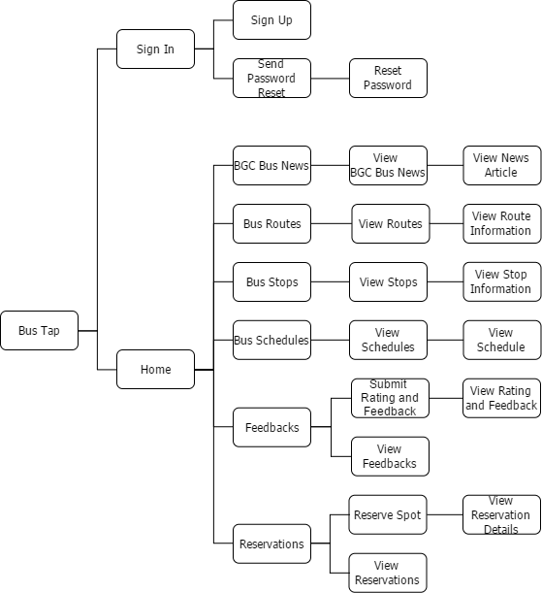

#### Web Application

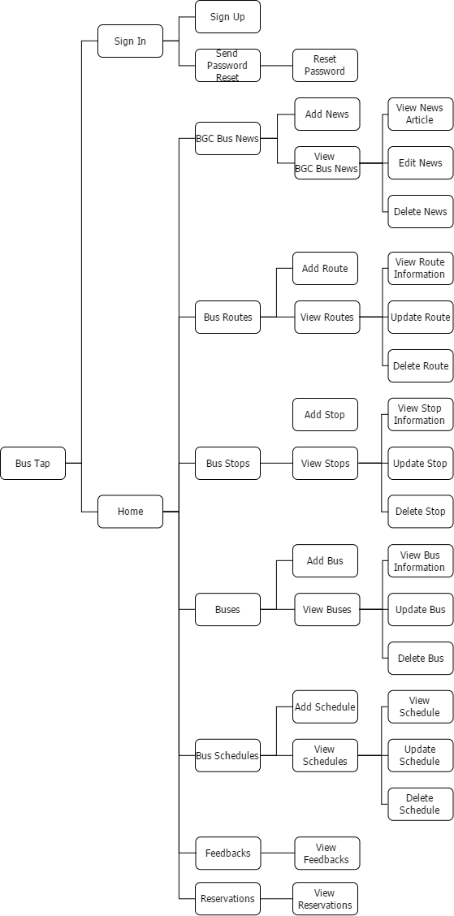

### Use Case Diagram

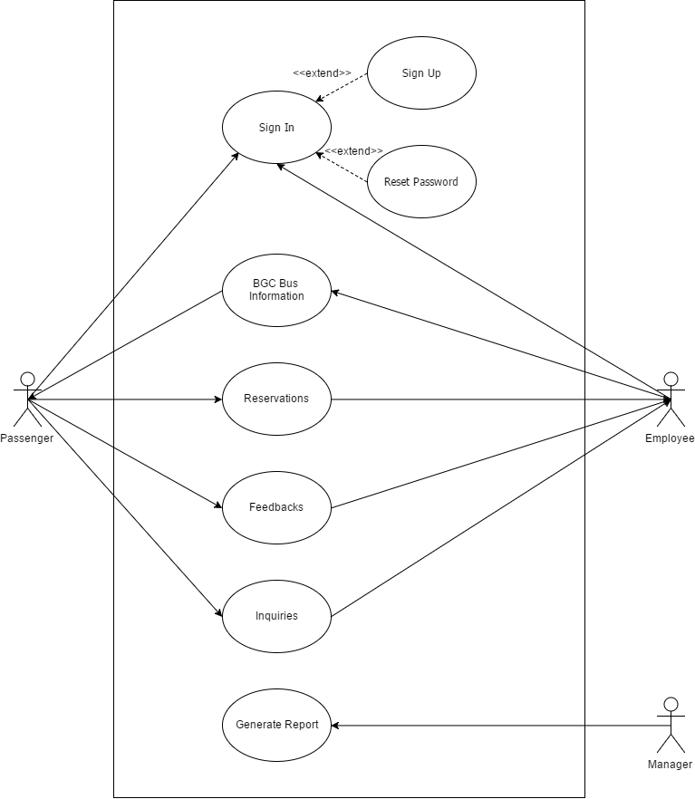

### Event Table

|  |  |  |  |  |  |
| --- | --- | --- | --- | --- | --- |
| **EVENT** | **TRIGGER** | **SOURCE** | **USE CASE** | **RESPONSE** | **DESTINATION** |
| Passenger wants to sign in | Sign In Details | Passenger | Sign In | Home Page | Passenger |
| Employee wants to post news, routes, stops, buses,  and schedules | Add | Employee | BGC Bus Information | View | Passenger |
| Passenger wants to reserve a spot  on a bus | Reserve | Passenger | Reservations | Reservation Details | Employee |
| Passenger wants to submit rating  and feedback | Submit Rating and Feedback | Passenger | Feedbacks | View Feedbacks | Employee |
| Passenger wants to send an inquiry | Send Inquiry | Passenger | Inquiries | View Inquiries | Employee |
| Manager wants to generate reports | Report Request | Manager | Generate Reports | Report | Manager |

### Data Flow Diagram

#### Data Flow Diagram Context Diagram

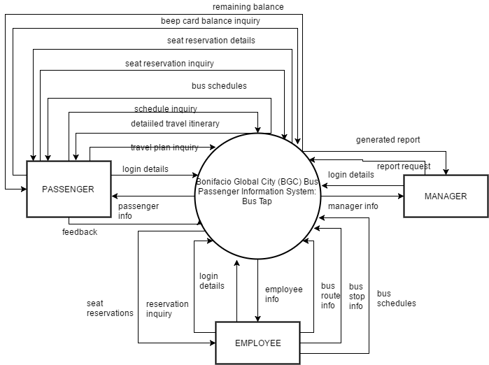

#### Data Flow Diagram Level 0

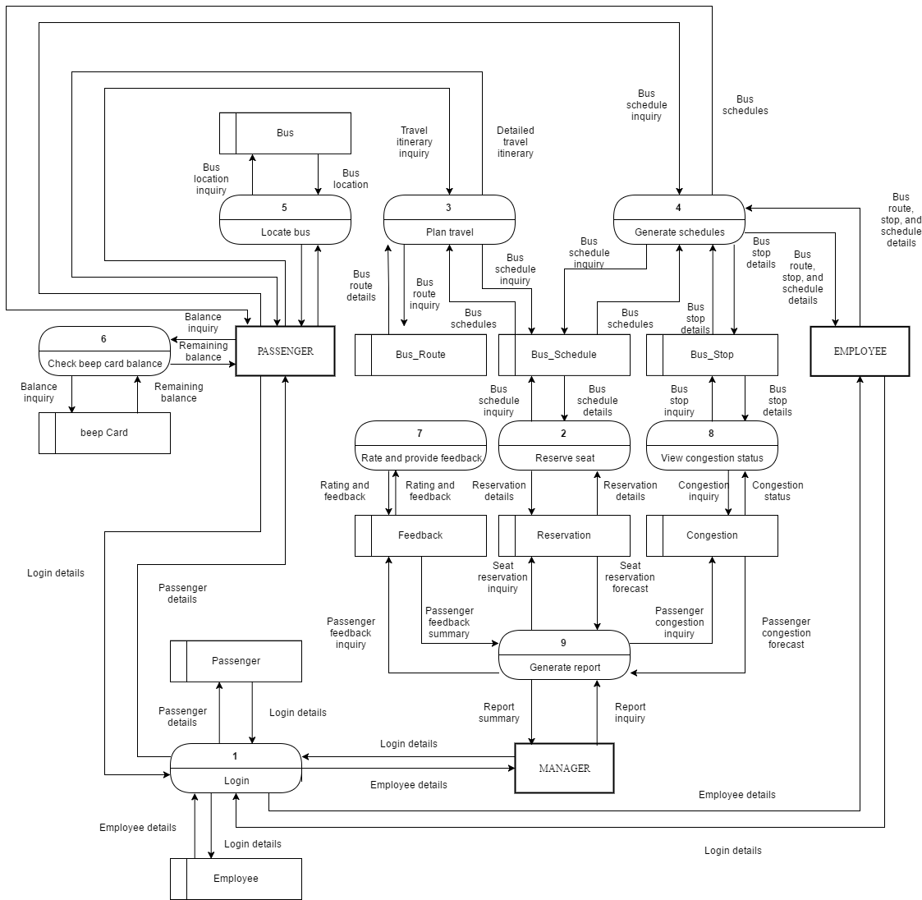

### Entity Relationship Diagram

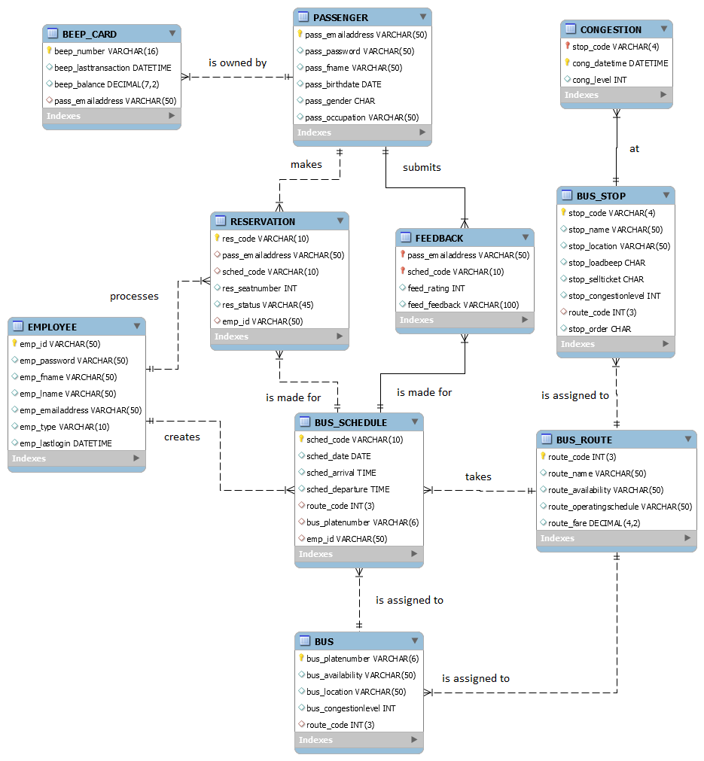

### Object Diagram

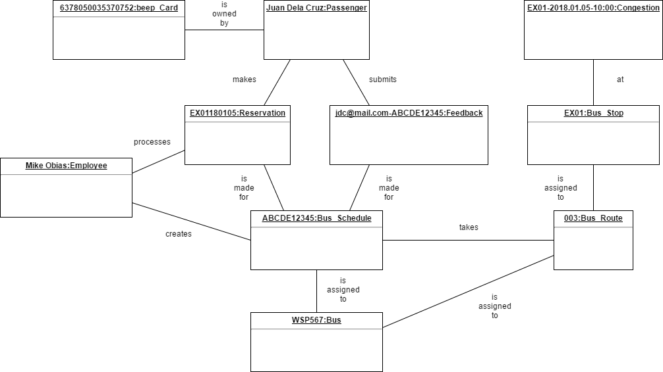

### Class Diagram

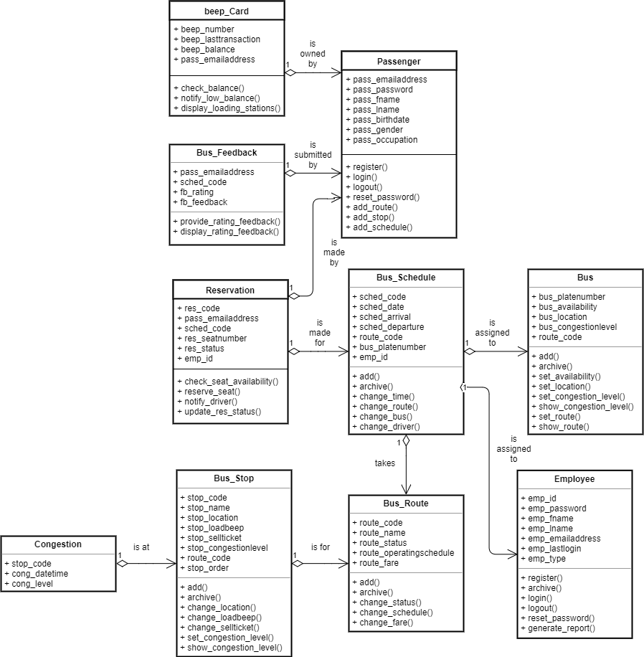

### Activity Diagram

Activity diagram for Use Case: Login

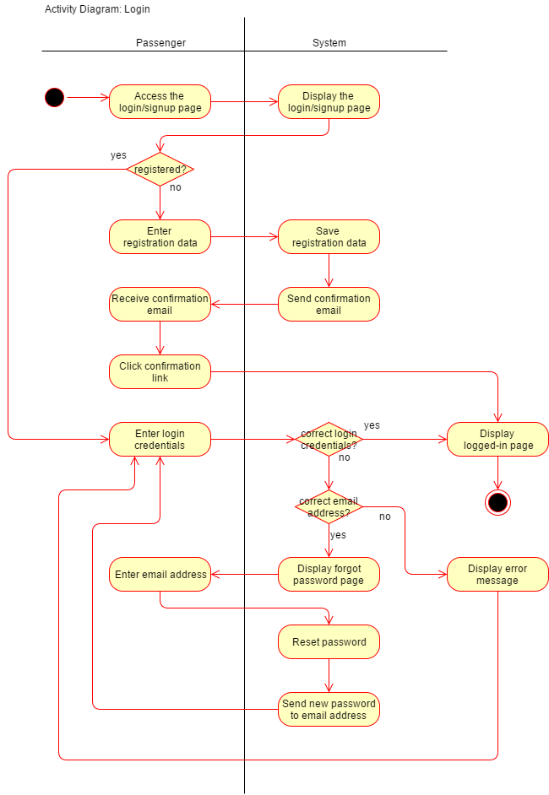

Activity diagram for Use Case: Reserve seat

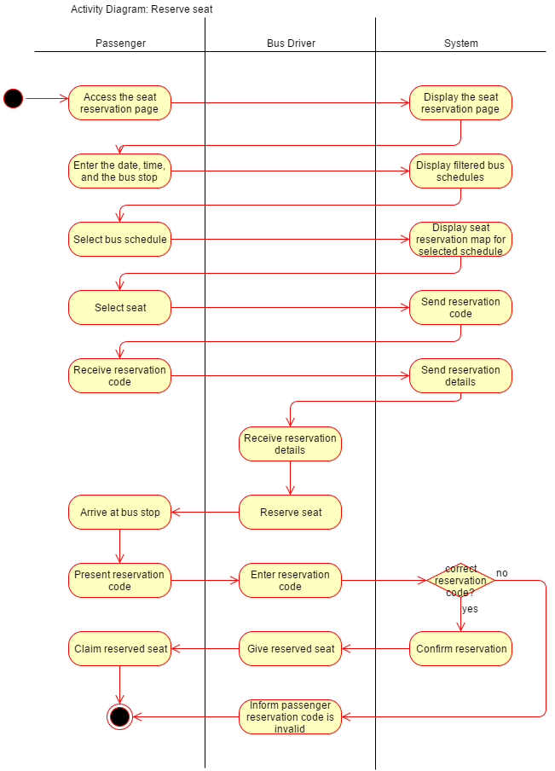

Activity diagram for Use Case: Generate bus schedules

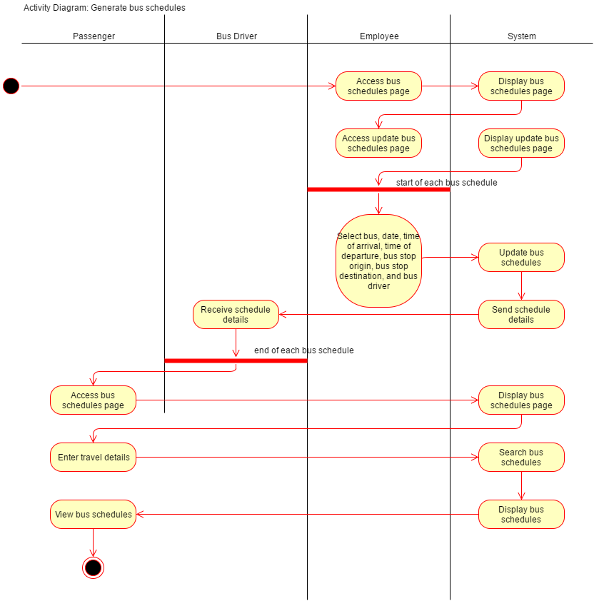

Activity diagram for Use Case: Rate and provide feedback

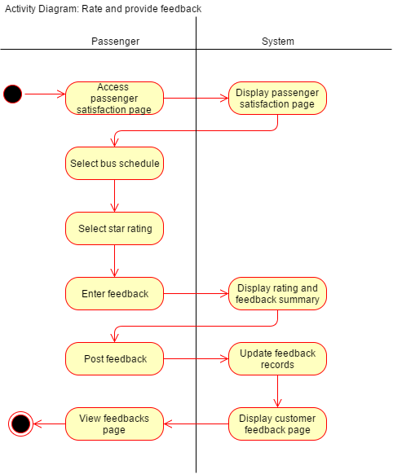

### Sequence Diagram

Sequence diagram for Use Case: Login

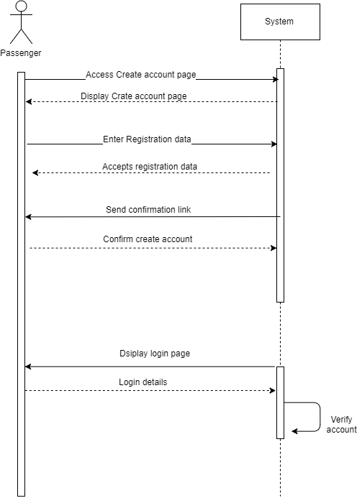

Sequence diagram for Use Case: Reserve seat

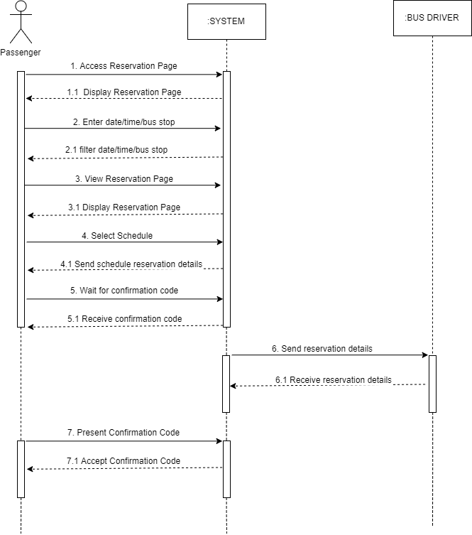

Sequence diagram for Use Case: Generate bus schedules (employee)

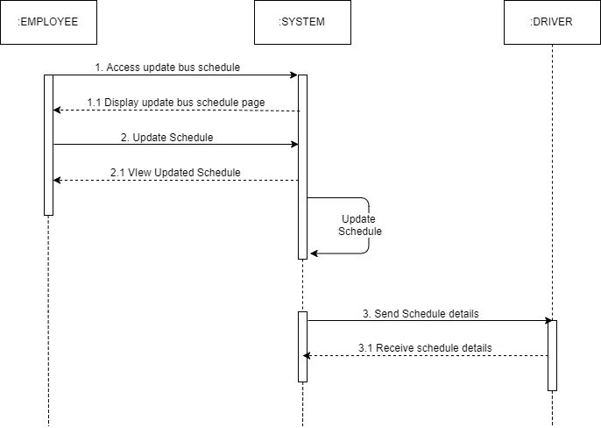

Sequence diagram for Use Case: Generate bus schedules (passenger)

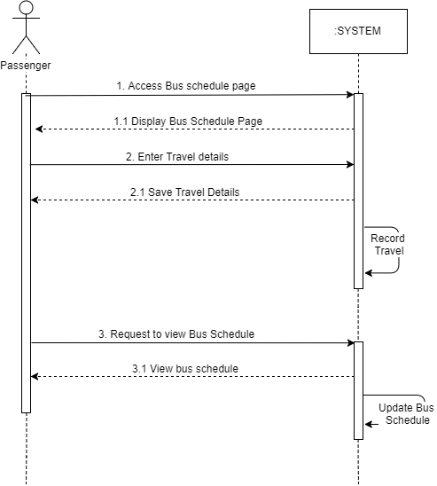

Sequence diagram for Use Case: Rate and provide feedback

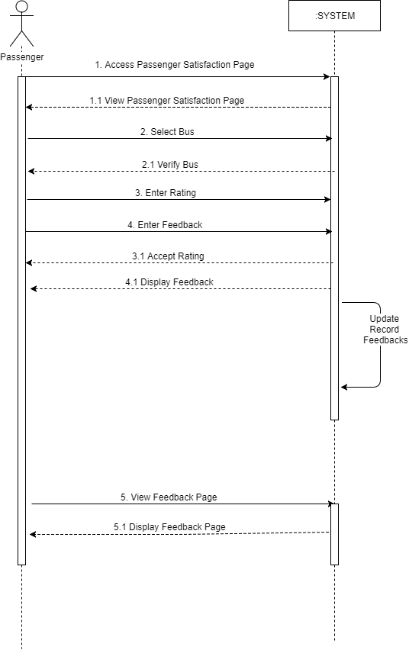

Sequence diagram for Use Case: Generate report

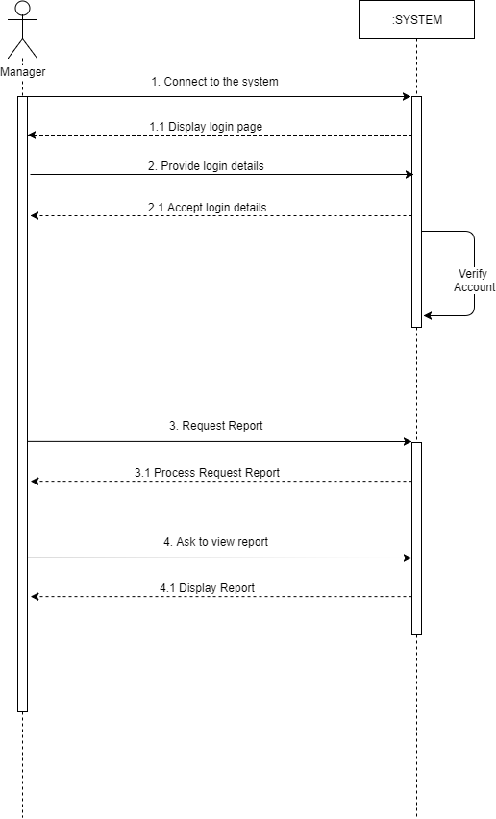

### **State Machine Diagram**

State Machine diagram for Object: Passenger

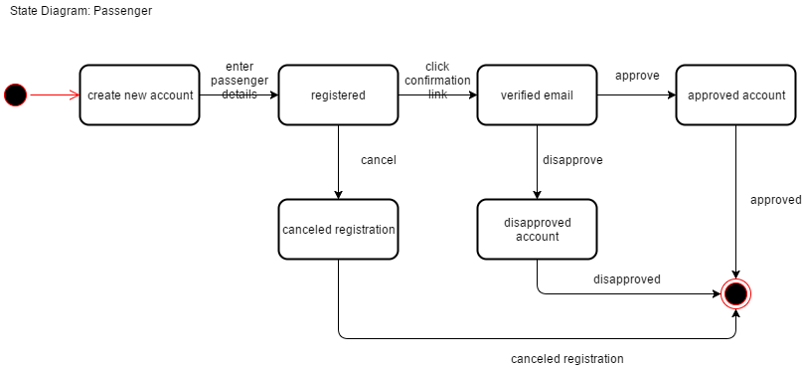

State Machine diagram for Object: Reservation

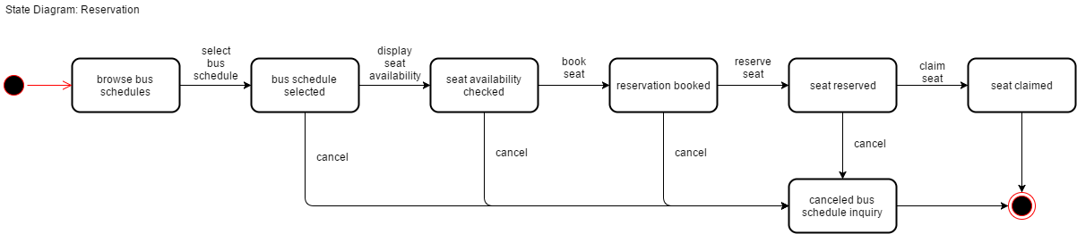

State Machine diagram for Object: Feedback

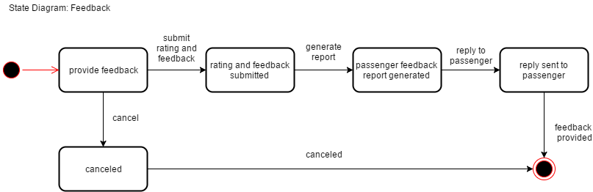

State Machine diagram for Object: Bus

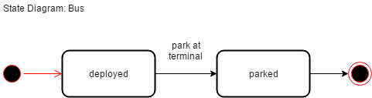

State Machine diagram for Object: Bus Schedule

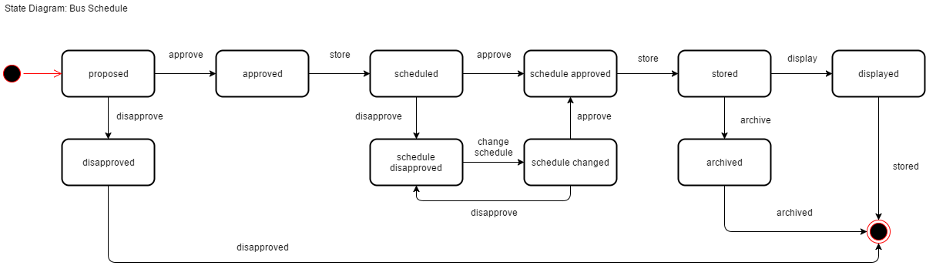

State Machine diagram for Object: Employee

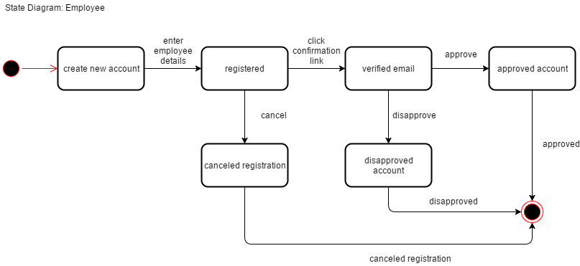

State Machine diagram for Object: Bus Route

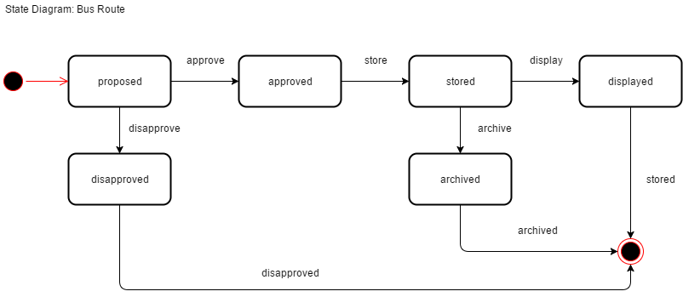

State Machine diagram for Object: Bus Stop

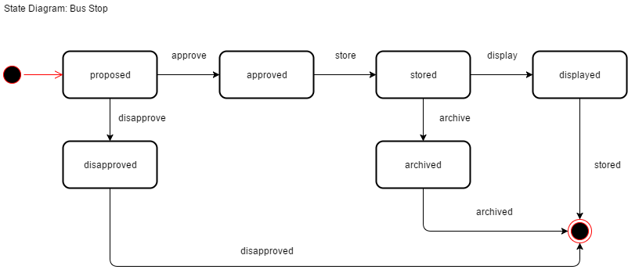

### **Timing Diagram**

Timing diagram for Object: Passenger

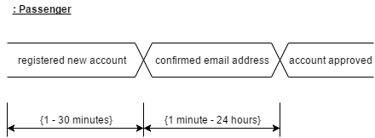

Timing diagram for Object: Reservation

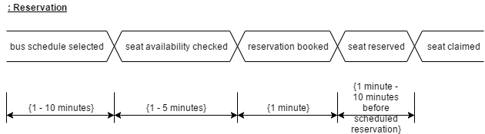

Timing diagram for Object: Feedback

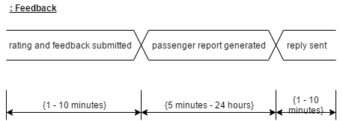

Timing diagram for Object: Bus

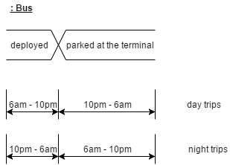

Timing diagram for Object: Employee

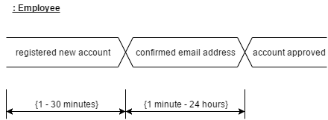

### **Communication Diagram**

Communication diagram for Use Case: Reserve seat

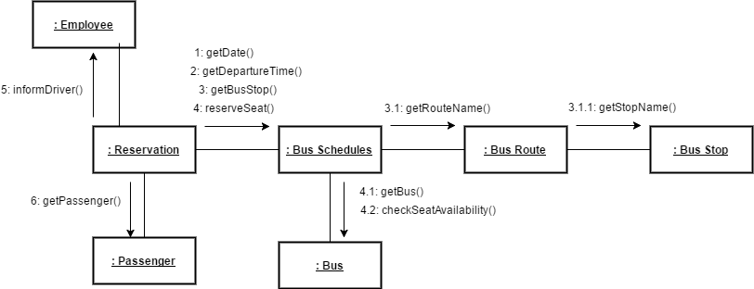

Communication diagram for Use Case: Display bus schedules

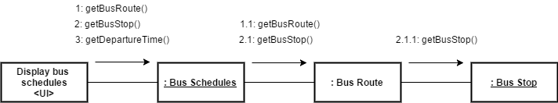

### **Package Diagram**

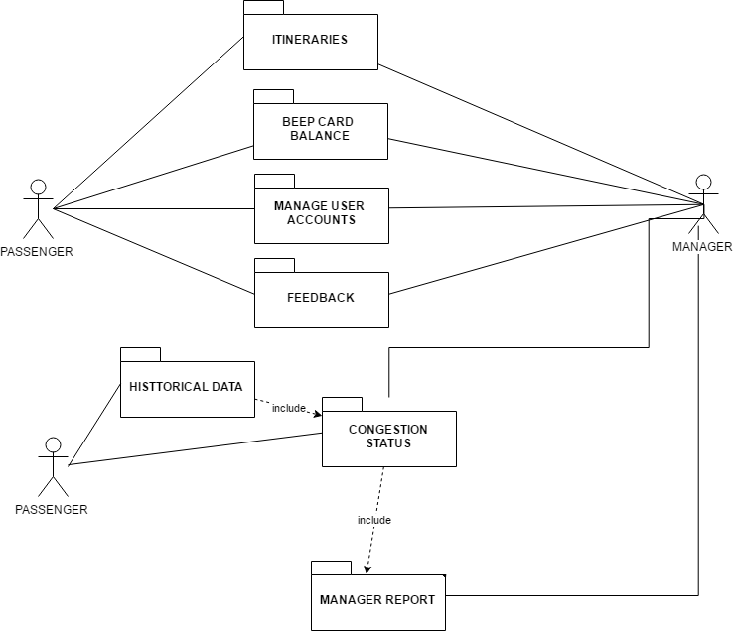

### **Component Diagram**

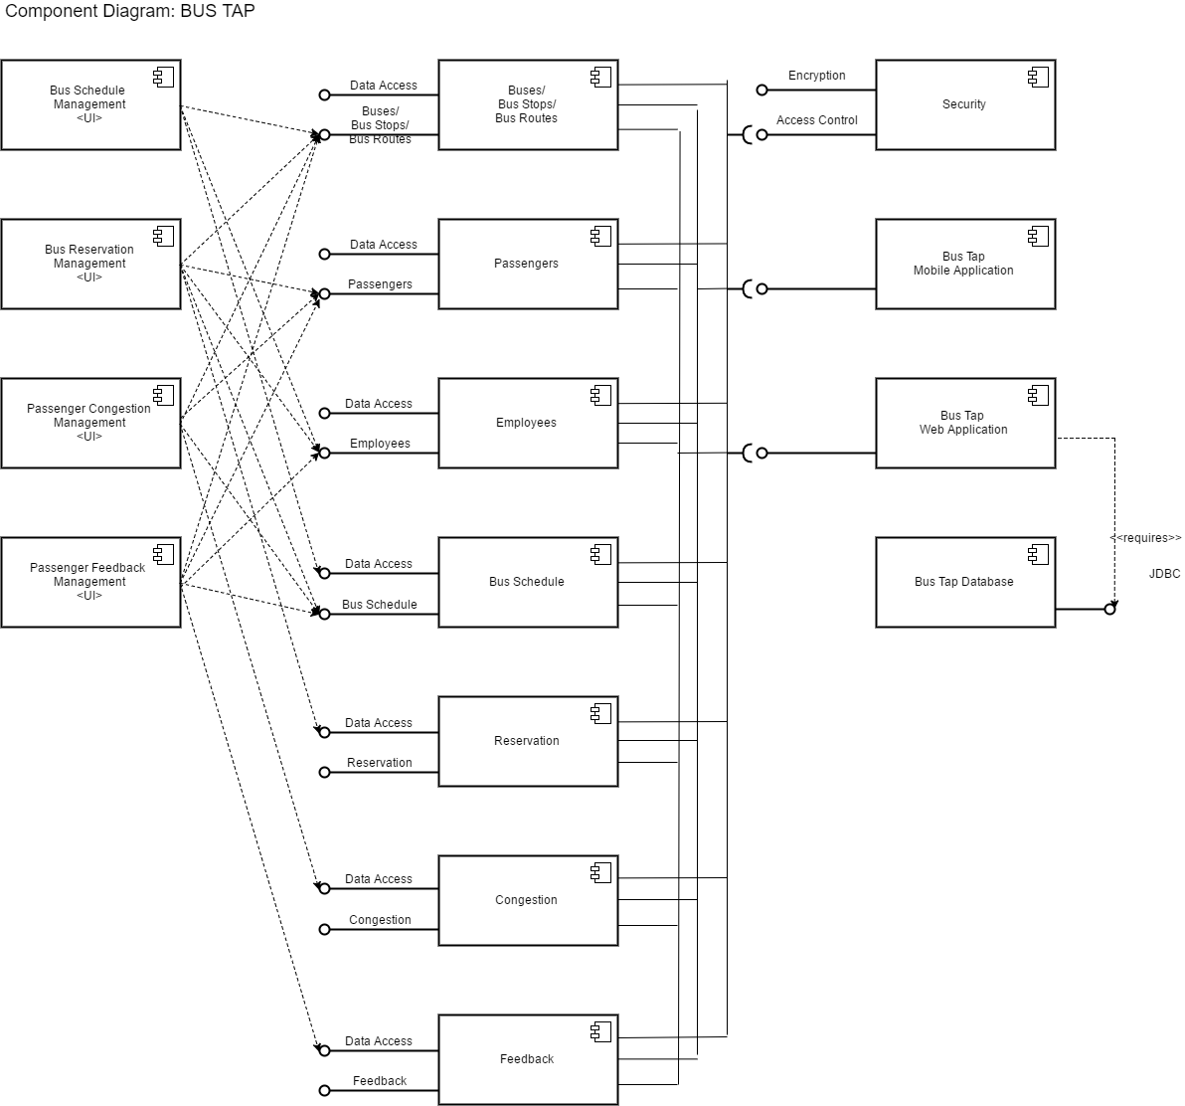

### **Deployment Diagram**

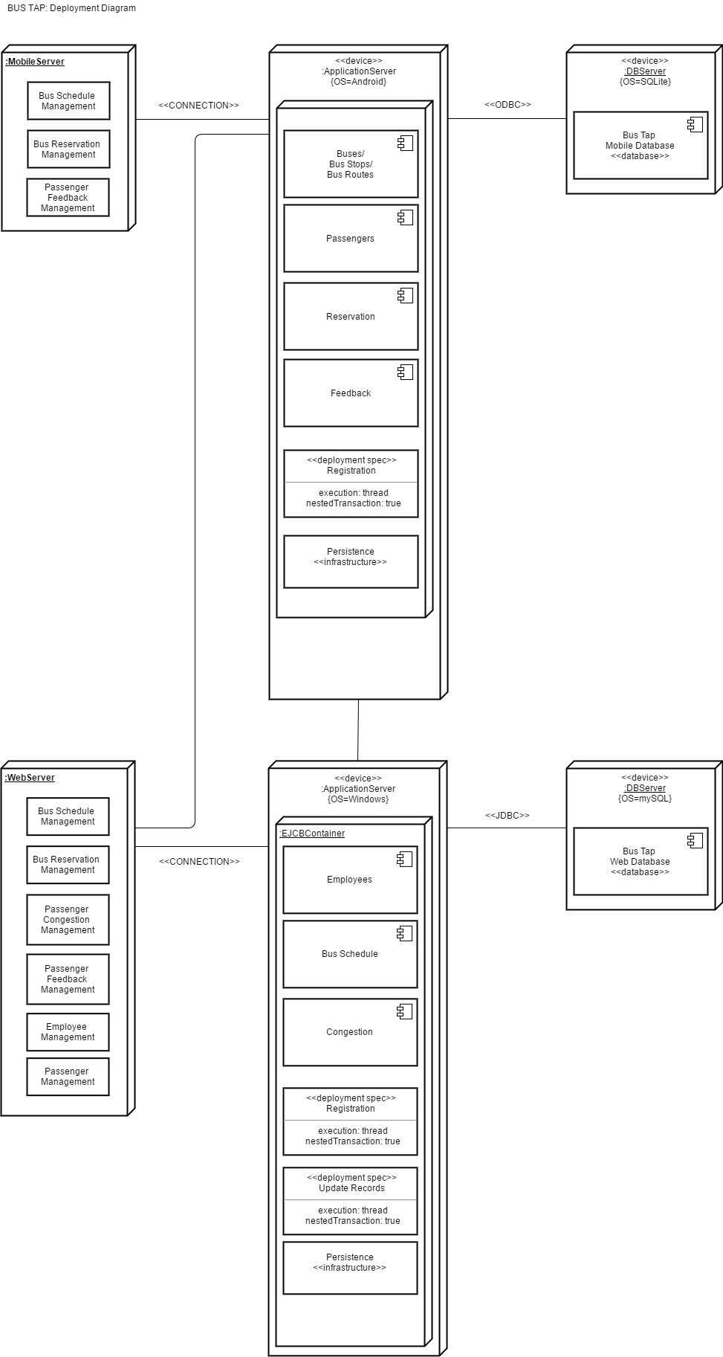

### **Composite Structure Diagram**

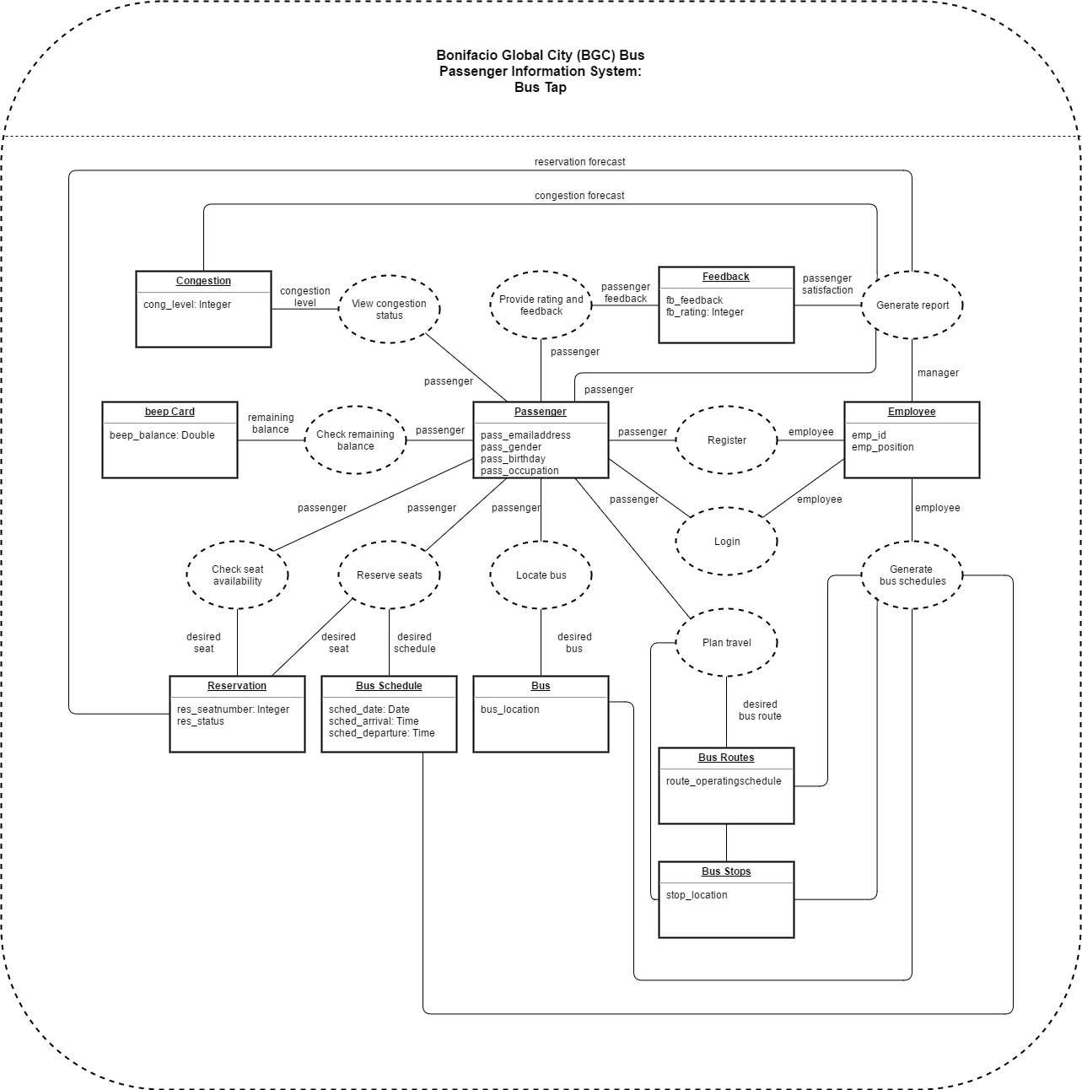

### **Interaction Overview Diagram**

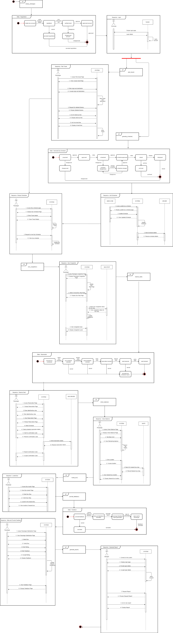

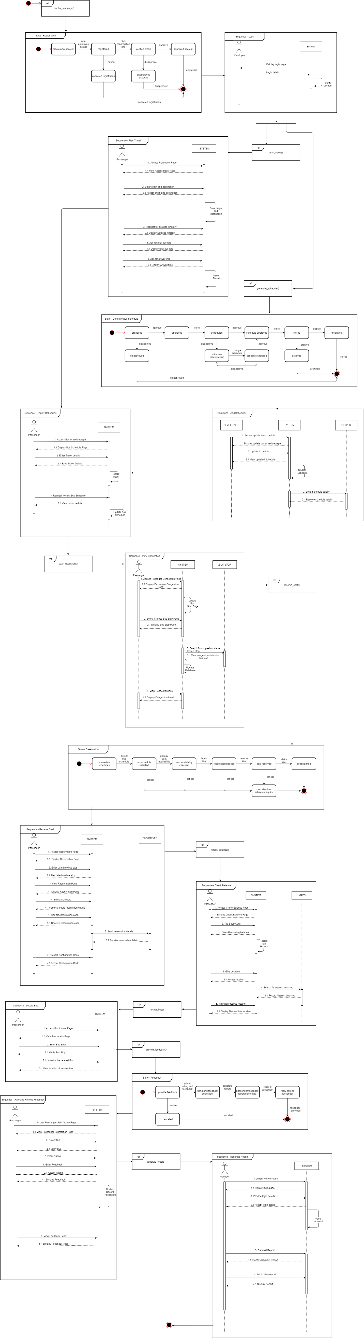





## Development and Testing

The mobile application was developed using the Android Studio IDE. The web application was developed using the Visual Studio Code IDE. The web application runs via localhost of the computer. Database of the website also runs via localhost of the computer.

## Description of the Prototype

The mobile application of the Bus Tap consists of the

* Welcome Page,
* Sign In Page,
* Sign Up Page,
* Forgot Password Page,
* Menu Page,
* News Page,
* Maps Page,
* Routes Page,
* Feedback Page, and
* Reservation Page.

The web application of the Bus Tap consists of the

* Sign In Page,
* Sign Up Page,
* Reset Password Request Page,
* Reset Password Page,
* Home Page
* Bus Routes Page (View All, Add, Update, and View One)
* Bus Stops Page (View All, Add, Update, and View One)
* Buses Page (View All, Add, Update, and View One)
* Bus Schedules Page (View All, Add, Update, and View One)
* News Page (View All, Add, Update, and View One)
* View Rating and Feedback Page

The Sign Up Page, Sign In Page, Reset Password Page, and Reset Password Request Page allows of the mobile and web application allows the users to create an account and to access them. The Menu Page of the mobile application and the Home Page of the web application allows users to access the different pages upon signing in. The News Page, Routes Page, Bus Stops Page, Buses Page, and Bus Schedules Page allows the employee to post news, route information, stop information, bus information, and trip information and the passengers to view the posts. The Feedback Page allows the passengers to provide rating and feedback, which can be seen by the company. The Reservation Page allows the passengers to make a reservation and for the company to receive the reservation.

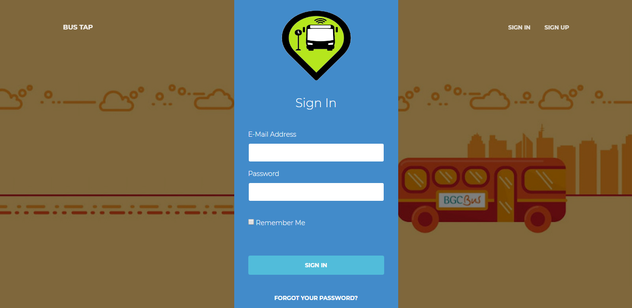

Figure 1. Web Application – Sign In Page

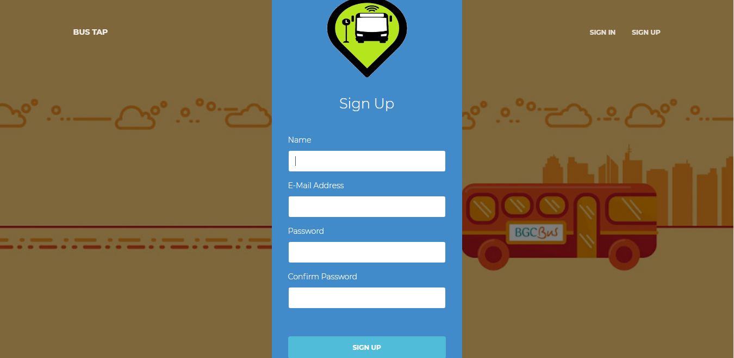

Figure 2. Web Application – Sign Up Page

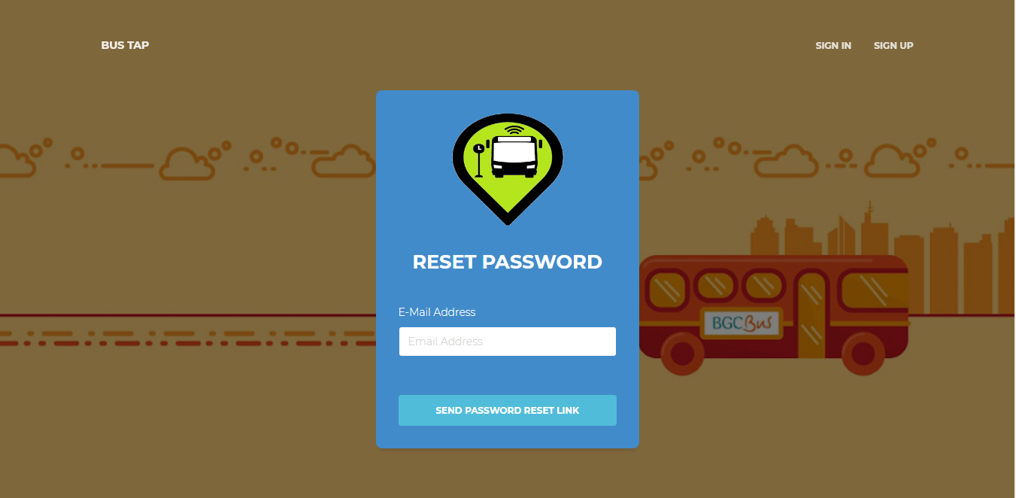

Figure 3. Web Application – Send Password Reset Link Page

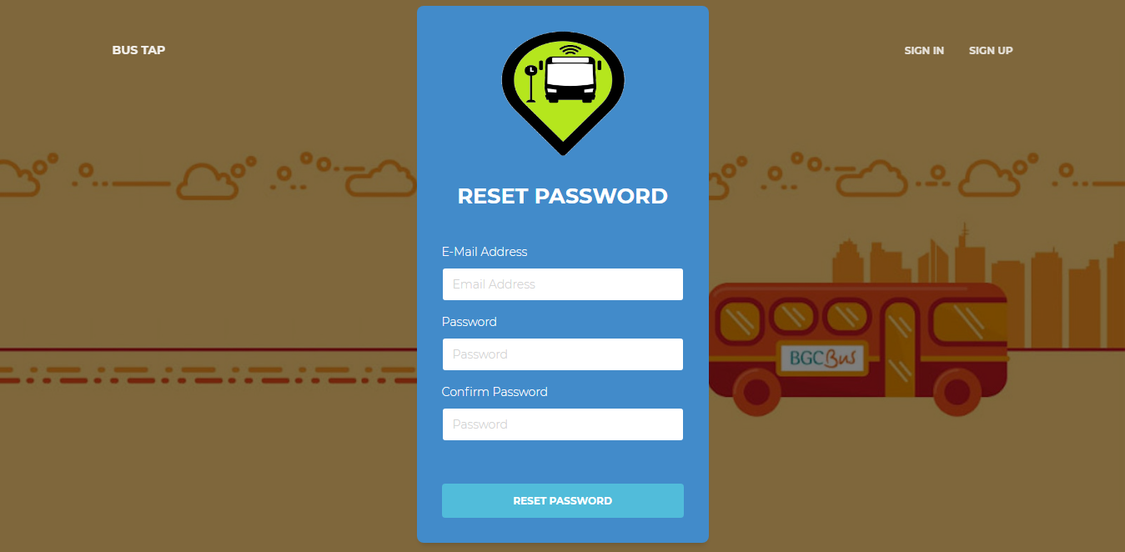

Figure 4. Web Application – Reset Password Page

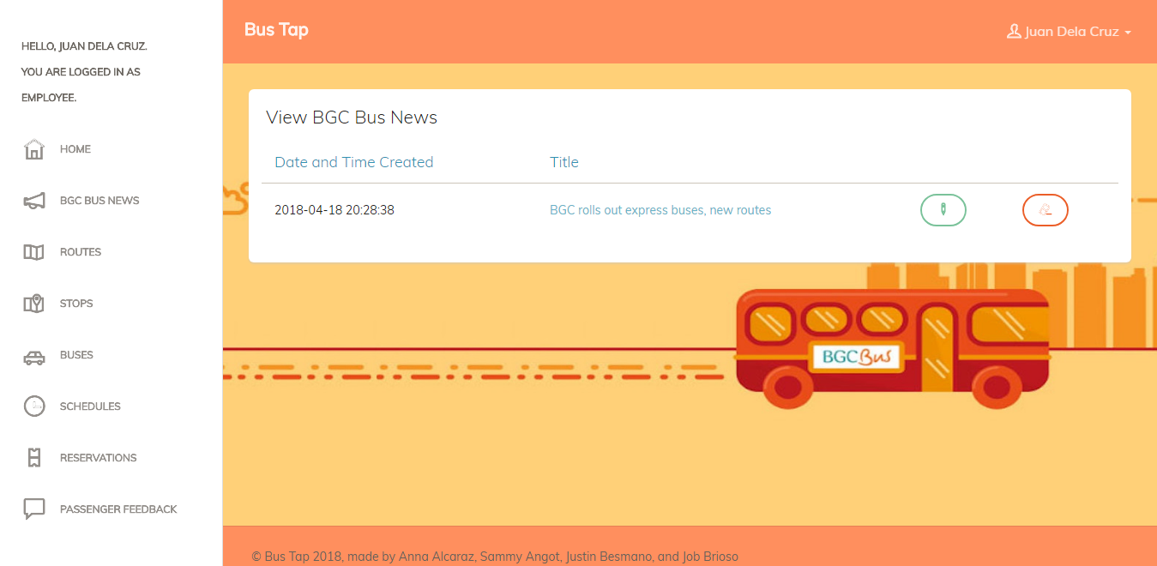

Figure 5. Web Application – BGC Bus News Page

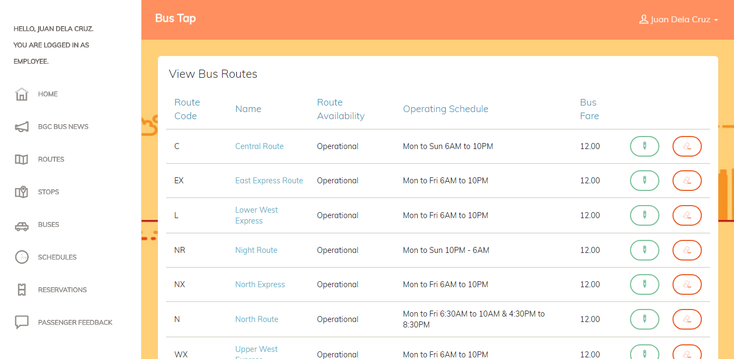

Figure 6. Web Application – Bus Routes Page

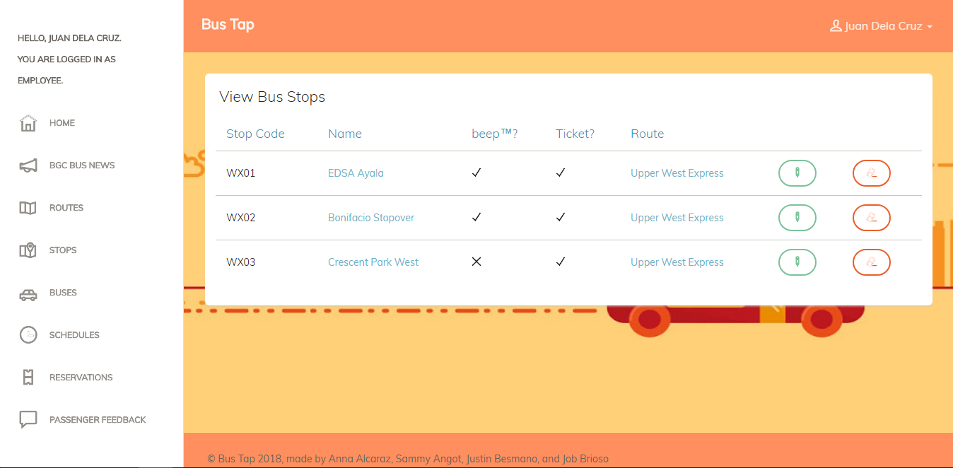

Figure 7. Web Application – Bus Stops Page

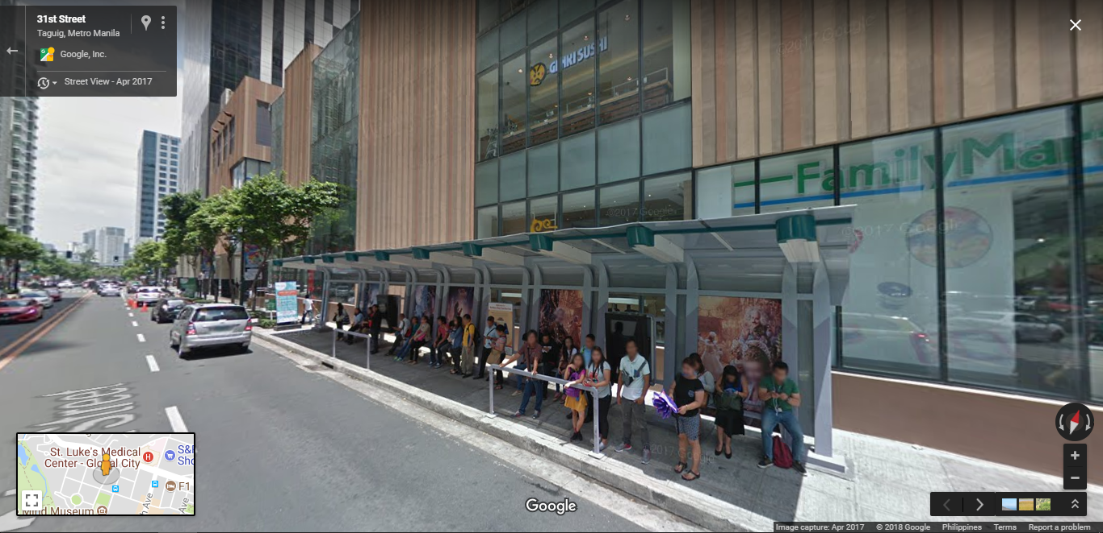

Figure 8. Web Application – Stop Location Page

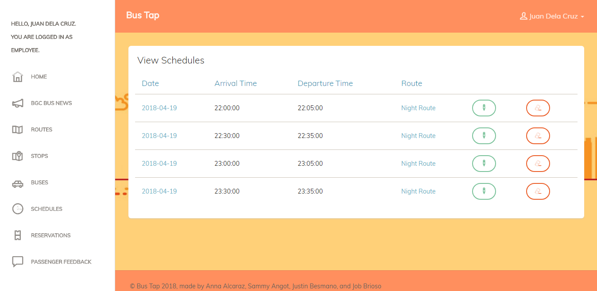

Figure 9. Web Application – Bus Schedules Page

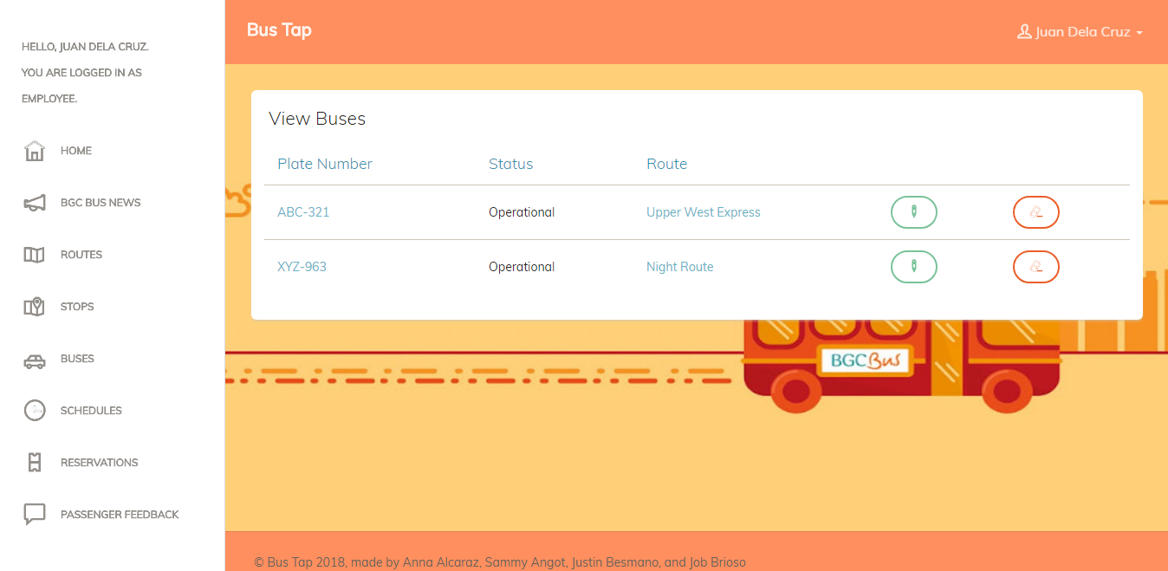

Figure 10. Web Application – Buses Page

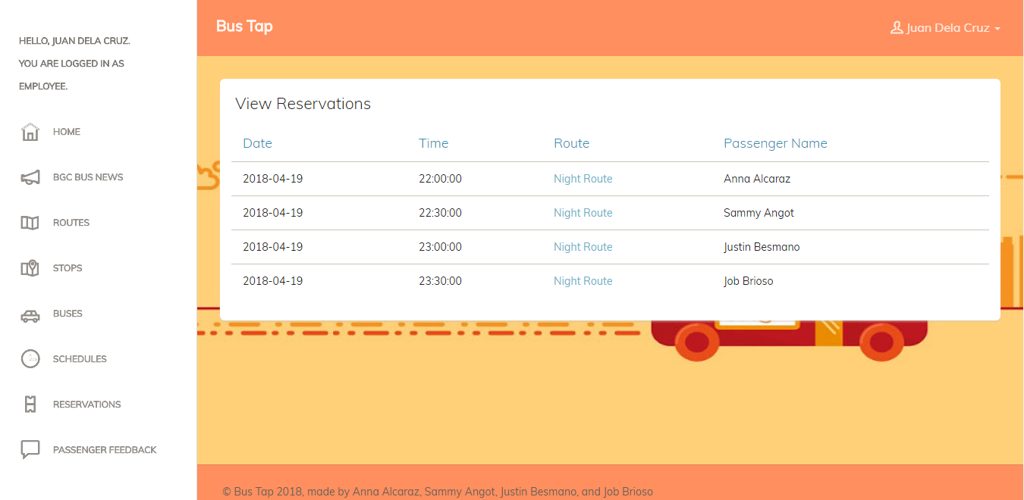

Figure 11. Web Application – Reservations Page

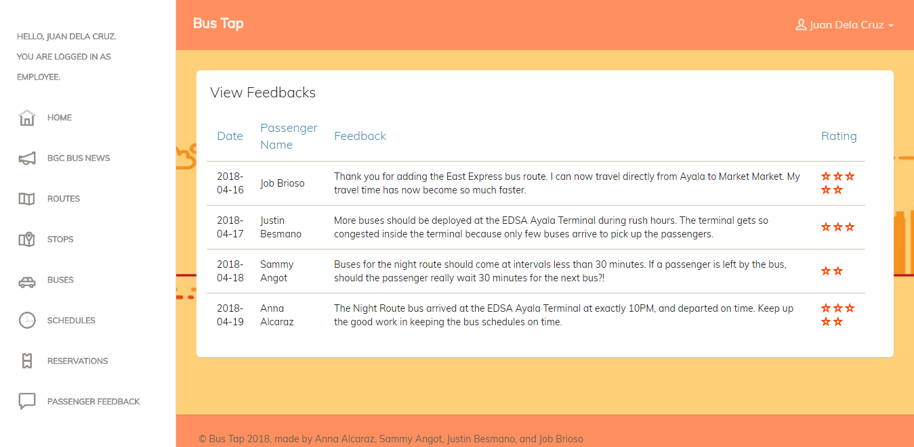

Figure 12. Web Application – Feedbacks Page

# Conclusions and Recommendations

The group created a mobile application as front-end and a web application as back-end for the Bus Tap, a passenger information system, that aims to connect the BGC Bus company to its passengers. Through the Bus Tap, the BGC Bus company can provide its passengers with the latest information regarding their services, and passengers can access up-to-date information regarding BGC Bus. Passengers can also contact the BGC Bus company through the mobile application, and provide rating, feedback, suggestions, or send inquiries, and receive replies.

With the Bus Tap reservation feature, passengers no longer have to wait long to be able to ride the bus, having been able to reserve a spot on their desired schedule ahead of time, minimizing the waiting time they experience when taking the BGC Bus.

# References

Obias, M. (2017, August 9). BGC Bus. (A. C. Alcaraz, S. M. Angot, J. V. Besmano, & J. G. Brioso, Interviewers)

Todd, A., & Barraclough, C. (2017, June 28). *What is Android OS*. Retrieved from recombu.com: https://recombu.com/mobile/article/what-is-android-and-what-is-an-android-phone\_M12615.html#

Trapeze Group. (n.d.). *Passenger Information Systems: What Transit Agencies Need To Know.* Retrieved from Trapeze Group Web site: http://www.trapezegroup.com/uploads/resources/Trapeze\_WP\_Passenger\_Info\_FIN.pdf

# Appendices

## Data Gathering

### Letter of Request for Interview to the management of the BGC Bus



3 August 2017

MR. JAIME FRANCISCO T. GALVEZ, JR.

General Manager

Bonifacio Transport Corporation

Utility Area 31st Street

Crescent Park West Bonifacio Global City

DEAR MR. GALVEZ:

Greetings!

We are 3rd year students of Asia Pacific College, under the BS Computer Science program, specializing in Systems Software. We are currently enrolled in an Introduction to Systems Analysis and Design (INTSDEV) course that requires students to complete an industry-based project of developing systems or applications for a company, government agency, or institution.

Public transportation, particularly the BGC Bus, has been the interest of our group. We aim to learn more about the business process of the BGC Bus, and to identify issues and problems encountered by the management and the passengers of the BGC Bus, to be able to propose a suitable system or application that will help not only the management of the BGC Bus, but also its passengers.

In this light, we would like to request for an interview with you or your representative on August 9, 2017 between 2:00-5:00PM in your office. We have at least 20 questions and might take about 45 minutes of the interviewer’s time. Attached herewith is the list of interview questions.

If you have some inquiries or clarifications, or if you would like to set the interview on a different date and time, please feel free to get in touch with our project manager, Anna Lynn Alcaraz, at 09998845654, or through e-mail at acalcaraz@student.apc.edu.ph.

Thank you in advance.

Sincerely,

|  |  |  |  |
| --- | --- | --- | --- |
| ANNA LYNN C. ALCARAZ  Project Manager | SAMMY BOY M. ANGOT  Team Member | JUSTIN V. BESMANO  Team Member | JOB G. BRIOSO  Team Member |

Noted by:

|  |  |
| --- | --- |
| MS. RHEA-LUZ VALBUENA  Course Instructor | MR. JUSTIN DAVID PINEDA  Project Adviser |

### Questions for the Interview with the management of the BGC Bus



**Interview Questions: Bonifacio Transport Corporation**

1. What is the daily average total number of passengers of the BGC Bus?
2. How many passengers ride the BGC Bus in every month? If possible, please specify for each month of the year.
3. What are the different bus routes of the BGC Bus?
4. Which route caters to the most number of passengers? Which route caters to the least number of passengers?
5. For each bus route, what are the operating hours?
6. What are the peak hours and off-peak hours? If peak hours and off-peak hours vary for each bus route, please specify.
7. For each bus route, how many buses are deployed during peak hours, and during off-peak hours?
8. Are the buses of the BGC Bus equipped with GPS? If yes, may the group be allowed to use the GPS for our app or system?
9. Are the buses of the BGC Bus equipped with CCTV? If yes, may the group be allowed to use the CCTV for our app or system?
10. Is there a fixed schedule for bus arrival and bus departure?
11. Between each bus, what is the time interval during peak hours, and during off-peak hours?
12. What is the average waiting time of passengers during peak hours, and during off-peak hours?
13. How much is the bus fare for each bus route?
14. Which bus stops or terminals have loading stations and/or ticket booths?
15. Are the bus stops or terminals equipped with CCTV? If yes, may the group be allowed to use the CCTV for our app or system?
16. Can a new mode of payment, other than the beep™ card, be allowed?
17. What are the problems or difficulties encountered by the BGC Bus?
18. What are the strategies employed to accommodate additional passengers during peak hours?
19. How are announcements regarding the operations of the BGC Bus posted to the public?
20. What technology is used by the BGC Bus to predict the number of minutes until the arrival of the next bus?

### Interview Transcript

Interviewer: Anna Lynn C. Alcaraz, Sammy Boy M. Angot, Justin V. Besmano, Job G. Brioso

Interviewee: Mr. Mike Obias, Assistant Operation Manager, BGC Bus

Date: August 9, 2017

Time: 4:00 PM

Venue: Bonifacio Transport Corporation

Utility Area 31st Street

Crescent Park West, Bonifacio Global City

(start of interview)

Interviewer: What is the daily average total number of passengers of the BGC Bus? How many passengers ride the BGC Bus in every month?

Interviewee: Right now, we have 44,000 passengers on weekdays, and half of that on weekends. So, during Saturdays and Sundays, 20,000. In a month, we have almost 1,000,000 passengers.

Interviewer: Which months have the highest number of passengers, and which months have the lowest number of passengers?

Interviewee: Before, during March to June, we have less passengers, compared to the other months because those months are usually the students’ summer vacation; however, because some universities moved the start of their academic calendar, we noticed a decrease in passengers during July to September. But the month with the lowest ridership is March because it has lots of holidays, like Holy Week. Whenever there is a long holiday, we always have the lowest ridership.

Interviewer: What are the different bus routes of the BGC Bus?

Interviewee: Just last Monday, August 7, we recently implemented improved bus routes for the BGC Bus. We have 7 new regular routes that run from 6AM to 10PM. Then, we also have the augmentation, or what we call the extension routes. These extension routes travel to places outside BGC, like Ayala, we call it Ayala Route or Ayala Express. The second one is Arca South. It travels from here to Arca. Then the third one is the North Route, though the North Route still travels within BGC, but the North is handled by Megaworld, unlike BGC, which is handled by FBDC Ayala.

Interviewer: Which route caters to the most number of passengers? Which route caters to the least number of passengers?

Interviewee: So far, the route with the highest recorded number of passengers is the West Route. It is the combination of the Upper West and Lower West. Before it was just the West Route, but we split it into Upper and Lower. The West side of BGC Bus is here, where the office of the BGC Bus is located, and the East part is Market! Market! The route with the least number of passengers is the route going to Kalayaan. We recently implanted this route, just two months ago. It only runs for 4 hours in the morning on weekdays. Right now, it only has 100 pax.

Interviewer: For each bus route, how many buses are deployed for each route?

Interviewee: The amount of buses deployed to each route depends on the availability. But right now, our fleet is composed of 51 buses. The route with the most buses being deployed to is the one with the highest ridership, the West, followed by the East, then the other routes.

Interviewer: What is the capacity of the bus?

Interviewee: The buses have perimeter seating. In has a seating capacity of 37 passengers, but the bus can accommodate 75 passengers comfortably. The maximum capacity of the bus is 90 passengers.

Interviewer: What are the peak hours and off-peak hours?

Interviewee: Peak hours apply to all the routes. Peak hours are 6AM to 10AM and 4PM to 8PM.

Interviewer: Are the buses of the BGC Bus equipped with GPS? If yes, may the group be allowed to use the GPS for our app or system?

Interviewee: All buses are equipped with GPS.

Interviewer: Are the buses of the BGC Bus equipped with CCTV? If yes, may the group be allowed to use the CCTV for our app or system?

Interviewee: The buses are not yet equipped with CCTV, but we are planning to equip them. The challenge is for real-time streaming. The plan is to equip each bus with 4 CCTVs. But the challenge is with the bandwidth.

Interviewer: Are the bus stops or terminals equipped with CCTV? If yes, may the group be allowed to use the CCTV for our app or system?

Interviewee: The terminals are equipped with CCTVs but some of the stops don’t. But aside from the CCTV of the BGC Bus, we also have the city CCTVs. These stops are within range of the city CCTVS.

Interviewer: Is there a fixed schedule for bus arrival and bus departure?

Interviewee: We have a fixed schedule.

Interviewer: Between each bus, what is the time interval during peak hours, and during off-peak hours? What is the average waiting time of passengers during peak hours, and during off-peak hours?

Interview: The standard waiting time is 10 minutes. Every passenger should only wait, at most, for 10 minutes. That’s our goal here. For the actual, it varies depending on the traffic, the speed of the bus.

Interviewer: How much is the bus fare for each bus route?

Interviewee: We have a fixed fare price of P12 for all routes, except for Arca South and Nuvali, but that’s because they’re extension routes.

Interviewer: Which bus stops or terminals have loading stations and/or ticket booths?

Interviewee: Only selected stops have ticket booths. We encourage the passengers to use the beep™ cards. However, for stops near government offices, we have to deploy ticket sellers. These government offices have visitors that do not regularly travel within BGC. We cannot insist they buy their own beep™ cards. Stops with ticket sellers are Bonifacio Stopover, RCBC, Nutriasia, BGC Bus Bonifacio One Technology Tower terminal, BGC Bus Ayala terminal, and BGC Bus Market! Market! terminal. beep™ cards can be reloaded at the terminals.

Interviewer: What are the problems or difficulties encountered by the BGC Bus?

Interview: Passenger complaints.

Interviewer: Can you cite examples of complaints the BGC Bus has received from the passengers?

Interview: Mostly, passengers complain about the long line of passengers during rush hours, about having to wait long for the buses to arrive, and about how few the buses going around are.

(end of interview)

### Survey Questionnaire

Good day!

We are 3rd year students of Asia Pacific College, under the BS Computer Science program, specializing in Systems Software. For our Introduction to Systems Analysis and Design (INTSDEV) course this term, our group has to conduct a survey on passengers of the BGC Bus, as part of our data gathering for our project.

We would like to ask you to answer the following questions.

Thank you for your cooperation.

\_\_\_\_\_\_\_\_\_\_\_\_\_\_\_\_\_\_\_\_\_\_\_\_\_\_\_\_\_\_\_\_\_\_\_\_\_\_\_\_\_\_\_\_\_\_\_\_\_\_\_\_\_\_\_\_\_\_\_\_\_\_\_\_\_\_\_\_\_\_\_\_\_\_\_\_

Survey Questions:

Why do you ride the BGC Bus? (check all that apply)

☐ to go to school

☐ to go to work

☐ to go home

☐ to go to the mall

☐ others, please specify: \_\_\_\_\_\_\_\_\_\_\_\_\_\_\_\_\_\_\_\_

How often do you ride the BGC Bus in a week? (check one only)

⚪️ I don't regularly ride the BGC Bus

⚪️ 1-5 times a week

⚪️ 6-10 times a week

⚪️ 11-15 times a week

⚪️ more than 15 times a week

What are the problems you encounter when riding the BGC Bus? (check all that apply)

☐ long queue when buying bus ticket or loading beep™ card

☐ long queue when waiting for the bus

☐ inaccurate bus schedules

☐ congestion of passengers inside the bus

☐ others, please specify: \_\_\_\_\_\_\_\_\_\_\_\_\_\_\_\_\_\_\_\_

How do you pay for the BGC Bus fare? (check all that apply)

☐ bus ticket

☐ beep™ card

If you buy tickets, how many minutes do you usually take to buy bus tickets? (check one only)

⚪️ less than a minute

⚪️ 1-2 minutes

⚪️ 3-4 minutes

⚪️ 5 minutes or more

If you use the beep™ card, where do you load your beep™ card? (check all that apply)

☐ LRT stations

☐ MRT stations

☐ BGC Bus Ayala terminal

☐ BGC Bus Market! Market! terminal

☐ BGC Bus Bonifacio One Technology Tower terminal

☐ FamilyMart

☐ Circle K

☐ SM malls

How many minutes do you usually have to wait before boarding the bus? (check one only)

⚪️ 1-5 minutes

⚪️ 6-10 minutes

⚪️ 11-15 minutes

⚪️ 16-20 minutes

⚪️ 21-25 minutes

⚪️ 25-30 minutes

⚪️ more than 30 minutes

Will an app for the BGC Bus be useful to you? (check one only)

⚪️ yes

⚪️ no

What features of a BGC Bus app will be useful to you? (check all that apply)

☐ the app can give users step-by-step directions from origin to direction, with estimated travel time and fare

☐ the app can display a map indicating all bus routes, including stops and nearby landmarks for each bus route

☐ the app can display nearby locations of beep™ card loading stations on the map

☐ the app can display bus arrival times and departure times

☐ the app can display how many minutes until the next bus arrives at the bus stop

☐ the app can show the real-time location of the buses on the map

☐ users can check how long the lines are at each bus stop

☐ users can check the remaining balance on their beep™ card

☐ users can use their cellphone load to pay for the bus far

## 7.2 Curriculum Vitae

|  |  |  |
| --- | --- | --- |
| **Name:** | **ANNA LYNN C. ALCARAZ** | **CORPORATE photo**  Must fit in this box.  Strictly corporate attire. |
| **Complete Address:** | 37 Circle Drive, Cubic Homes |
| Merville, Parañaque |
| **Contact Number/s:** | Landline: 8220429 |
| Mobile No.: (0999) 884-5654 |
| **Email Address:** | [acalcaraz@student.apc.edu.ph](mailto:smangot@student.apc.edu.ph)  [annalynn.alcaraz@gmail.com](mailto:angot.sammy@gmail.com) |
| **Website:** | https://www.linkedin.com/in/anna-lynn-alcaraz/ |

|  |  |
| --- | --- |
| **Personal Statement** | Eager to learn and a goal-oriented person that seeks to create the best of what she can deliver and contribute to a team, and is also dedicated to build a career and to experience more on the field of technology. |
| Education | **Asia Pacific College**, Magallanes, Makati City  **Bachelor of Science in Computer Science**  **specializing in Systems Software**  January 2015-present |
| **Work-Related Courses** | * Database Management * Web Development * Systems Analysis and Design * Software Development * Project Management |
| **Academic Projects** | **Bus Tap**   * Passenger Information System for the Bonifacio Global City (BGC) Bus (Web and Mobile Application) * June 2017 – April 2018 * Project Manager, System Analyst, and Web Developer * Included in the MERGE 2018 exhibit of Asia Pacific College at the SM Mall of Asia (April 19-20, 2018)   **TaraNaSaPinas**   * Travel Deals Booking Application (Web and Mobile Application) * January 2018 – April 2018 * Web Developer   **Guru Job**   * Job Matching Platform for Educators (Web Application) * January 2018 – April 2018 * Software Quality Assurance Team Project Manager   **Magallanes Village Association Website**   * Official Website of the Magallanes Village Association * September 2017 – January 2018 * Project Manager and Systems Administrator |
| **Technical Skills** | Web Development:   * Joomla, * Laravel, and * Ruby on Rails   Languages:   * SQL * C++, JAVA, Visual Basic, * HTML, CSS, * PHP, Python, and Ruby |
| **Awards & Recognitions** | * **Dean’s Lister**, AY 2016-2017 |
| **Seminars & Trainings Attended** | * The Fight Against Counterfeiting   Asia Pacific College, April 2018   * Xamarin Application Development Workshop   Asia Pacific College, July 2016 |

|  |  |  |
| --- | --- | --- |
| **Name:** | **SAMMY BOY M. ANGOT** | **2x2 CORPORATE photo**  Must fit in this box.  Strictly corporate attire. |
| **Complete Address:** | 52 Ranger Street, South Signal Village, |
| Taguig City |
| **Contact Number/s:** | Landline: 837-7418 |
| Mobile No.: (0916) 697-8145 |
| **Email Address:** | [smangot@student.apc.edu.ph](mailto:smangot@student.apc.edu.ph)  [angot.sammy@gmail.com](mailto:angot.sammy@gmail.com) |
| **Website:** | <https://sg.linkedin.com/in/sammy-angot-284a7515b> |

|  |  |
| --- | --- |
| **Personal Statement** | Currently the Logistics Team Assistant Head of the APC Microsoft Community who is eager to accomplish work with compliance to a minimum time allotted and ensures what needs to be done. Humble and flexible to any teams that to be assigned.  Skilled in using Adobe Photoshop, Adobe Illustrator, Adobe Aftereffect, Adobe Dreamweaver, Android Studio and Vegas Pro, specializing for work presentations, system production and debugging maintenance, and multimedia creation for outsourcing clients. |
| **Education** | **Asia Pacific College**, Magallanes, Makati City  **B.S. Computer Science Major in Systems Software**  June 2015-present |
| **Work-Related Courses** | * Web Development * Mobile Development * Business Analysis |
| **Academic Projects** | **McShield**   * Anti-Malware Software,June. 2012 * Introduced to APC to be the standard anti-malware software * Documentation Head * Used as the standard by the APC School of Computing and Information Technologies, June 2016   **Smart Trash Can**   * Arduino-based microcontrollers and sensors * Functional prototype to send SMS to waste management authorities if trash bins are full * Prototype Assembly   **Bonifacio Global City (BGC) Bus Passenger Information System: Bus Tap**   * Mobile application that helps commuters riding the BGC Bus. * June 2017 – April 2018 * Project Analyst * Chosen to Exhibit Project in Merge 2.0, April 2018 |
| **Technical Skills** | * Highly skilled in Software Development and Multimedia * Intermediate skills in Programming and Video Production * Proficient in MS Office: Word, Excel, PowerPoint * Sufficient knowledge in System Design |
| **Seminars & Trainings Attended** | * Xamarin Workshop, Asia Pacific College, July 2016 * Internet of Things Seminar, Asia Pacific College, July 2017 * Xamarin Workshop, Asia Pacific College, July 2017 * Introduction to Azure Seminar, Asia Pacific College, July 2017 * How to be successful in Pitching Idea Seminar, July 2017 * Cognitive Services and Internet of Things Seminar, Asia Pacific College, July 2017 * Imagine Cup Seminar, Asia Pacific College, July 2017 |
| **Extra-Curricular Activities** | * Gaming Genesis, Member, SY 2015-2016 * Junior Philippine Computer Society, Member, SY 2015-2017 * APC Microsoft Community, Logistics Team Assistant Head, SY 2017-present |

|  |  |  |
| --- | --- | --- |
| **Name:** | **Justin V. Besmano** | C:\Users\jvbesmano\AppData\Local\Microsoft\Windows\INetCache\Content.Word\29852468_1720297984695188_565014887_n.jpg  . |
| **Complete Address:** | 676 E. Rodriguez Street, Malibay, |
| Pasay City |
| **Contact Number/s:** | Landline: N/A |
| Mobile No.: (0917) 333-9604 |
| **Email Address:** | [jvbesmano@student.apc.edu.ph](mailto:jvbesmano@student.apc.edu.ph)  [jvbesmano@gmail.com](mailto:jvbesmano@gmail.com) |
| **Website:** | [www.linkedin.com/in/justin-besmano/](file:///C:\Users\acalc\Downloads\www.linkedin.com\in\justin-besmano\) |

|  |  |
| --- | --- |
| **Personal Statement** | A recent student of Asia Pacific College, achieving good grades in math and science related courses, who is looking to have a career as a system software analyst and/or developer to use and further develop my analytical and critical thinking ability.  A highly motivated individual who is into Project Management and Software development, has a good work ethic and an enthusiastic person who enjoys challenges in achieving personal and team goals.  Highly Skilled in web and mobile programming, especially android development for mobile and frameworks for web, proficient in web design, with proficient knowledge in JavaScript and CSS |
| **Education** | **Asia Pacific College**, Magallanes, Makati City  **BS Computer Science Major in Systems Software**  June 2015-present |
| **Work-Related Courses** | * Programming * Research * Software development * System Analysis |
| **Academic Projects** | **BGC Bus: Passenger Bus Information System**   * Bus Tap,April 2018 * Mobile Application * Lead Mobile Developer * Included in APC’s Merge 2.0 exhibit   **Eat-ToDo-Mo: Carinderia Finder**   * Carinderia Finder Application * January – April 2018 * Lead Developer   **Community Portal Application**   * Community portal web application * September – January 2018 * Project Manager |
| **Technical Skills** | * Highly skilled in Java Programming * Proficient in MS Office: Word, Excel, PowerPoint * Proficient in python, ruby programming language * Proficient in Web and Mobile Design |
| **Awards & Recognitions** | * 4th Place, ORSP National Congress Quiz Bee, March 2017 * Dean’s List, Academic Year 2016-2017 * Dean’s List, Academic Year 2017-2018 |
| **Seminars & Trainings Attended** | * Operations Research Society of the Philippines National Congress, March 2017 |
| **Extra-Curricular Activities** | * Microsoft Community, Member, SY 2017-present * Junior Philippine Computer Society, Member, SY 2016-2017 |

|  |  |  |
| --- | --- | --- |
| **Name:** | **Job G. Brioso** | C:\Users\Ynna Brioso\Downloads\29920663_2080475412195979_1821235219_n.jpg  . |
| **Complete Address:** | MB 14 Unit 506 BCDA Diego Silang Village |
| Taguig City |
| **Contact Number/s:** | Landline: N/A |
| Mobile No.: (0956) 432 0167 |
| **Email Address:** | [jgbrioso@student.apc.edu.ph](mailto:jgbrioso@student.apc.edu.ph)  <briosojob@gmail.com> |
| **Website:** | N/A |

|  |  |
| --- | --- |
| **Personal Statement** | Presently a student of Asia Pacific College and is preparing to have a career in Systems development to enhance the knowledge that I have learn during my college years.  A team player and result oriented, ensuring that every task given is executed properly and efficiently.  Knowledgeable in information technology and software development proficient in web design, with experience knowledge in JavaScript and CSS. Hoping to pursue a fruitful career in the above mentioned proficiencies and subjects to be recognized as a proficient programmer from the reputed Asia Pacific College. |
| **Education** | **Asia Pacific College**, Magallanes, Makati City  **BS Computer Science Major in Systems Software**  June 2015-present |
| **Work-Related Courses** | * Programming * Research * Software development * System Analysis |
| **Academic Projects** | **BGC Bus: Passenger Bus Information System**   * Bus Tap,April 2018 * Included in APC’s Merge 2.0 exhibit |
| **Technical Skills** | * Highly skilled in Java Programming * Proficient in MS Office: Word, Excel, PowerPoint |
| **Extra-Curricular Activities** | * Junior Philippine Computer Society, Member, SY 2016-2017 |